Supplementary Appendix:
Evaluation of Visual Patient Predictive for Enhancing Level 3 Situation Awareness: Protocol for a Multicenter Randomized Computer-Based Simulation and Diagnostic Accuracy Study (True Positive Rate, Precision, Average Lead Time)

Cynthia A. Hunn¹, Hannes Bruns¹, Sebastian D. Sahli², Luca J. Wachtendorf², Johannes Schäfer³, Stefan Schwerin⁴, Achilles Delis⁵, Markus Kalisch⁶, Gaspar Dugac⁶, Arend Rahrisch¹, Max Ebensperger⁴, Karimitar Arian², Gregor Massoth⁵, Christopher Neuhaus³, Alina Dubatovka⁷, Greta Gasciauskaite¹, Tadzio R. Roche¹, David W. Tscholl¹

1: Institute of Anesthesiology and Perioperative Medicine, University Hospital Zurich, University of Zurich, Zurich, Switzerland
2: Department of Anesthesia, Critical Care and Pain Medicine, Beth Israel Deaconess Medical Center, Harvard Medical School, Boston, Massachusetts
3: Department of Anaesthesiology, Heidelberg University Hospital, Heidelberg, Germany
4: Department of Anesthesiology and Intensive Care, TUM University Hospital, Technical University of Munich, Munich, Germany
5: Department of Anesthesiology, University Hospital Bonn, Bonn, Germany.
6: Seminar for Statistics, ETH Zurich, Zurich, Switzerland
7: Department of Computer Science, ETH Zurich, Zurich, Switzerland
Table of Contents
Page 3: List of Therapeutic Interventions to Prevent a Deviation
Pages 4-5: Clinical Case Vignettes
Pages 7-13: Event timelines and vital sign trend plots for Scenario 1 and Scenario 2
List of Therapeutic Interventions to Prevent a Deviation
Which therapeutic measure would you prioritize in this specific situation?
- Increase oxygen delivery
- Decrease oxygen delivery
- Initiate chronotropic support (e.g., reduce anesthetic depth, administer atropine)
- Initiate heart rate reduction (e.g., provide analgesia, administer beta-blockers)
- Rule out ischemia/infarction
- Initiate vasopressor or volume therapy to increase blood pressure
- Administer antihypertensive therapy or analgesia to lower blood pressure
- Increase preload (e.g., administer intravenous fluids)
- Decrease preload (e.g., restrict fluids, administer diuretics)
- Increase respiratory rate (e.g., reduce anesthetic depth, adjust ventilator settings)
- Decrease respiratory rate (e.g., adjust ventilator settings)
- Increase tidal volume
- Decrease tidal volume
- Increase minute ventilation
- Decrease minute ventilation
- Initiate warming measures
- Initiate cooling measures
- Increase depth of anesthesia
- Decrease depth of anesthesia
- Adjust level of neuromuscular blockade
Clinical Case Vignettes
Case Story Scenario 1:
In this simulated intraoperative scenario, the participant is presented with a difficult cardiac procedure. The timeline of events unfolds as follows:
As the surgery begins, an initial challenge presents itself. The patient’s ECG monitor displays ST segment depression, an indication of myocardial ischemia. A temporary disruption of oxygen delivery to the heart muscle, possibly due to a blocked coronary artery, may account for this condition. Just as the medical team addresses the ST segment depression, the ECG monitor now shows ST segment elevations, which might signify reperfusion injury, or a complication related to the procedure. As the medical team addresses the pathological ECG changes, the patient experiences a brief episode of respiratory rate depression. Prompt intervention from the anesthesiologist leads to the recovery of the patient's respiratory rate.
While the degree of ST segment elevation continues to increase, the patient’s mean blood pressure steadily drops. This could be the result of a variety of factors, such as excessive bleeding, an adverse reaction to anesthetics, or cardiac decompensation in line with the ongoing signs of cardiac ischemia. The team responds by administering fluids and vasoactive medications to stabilize the blood pressure. As the surgery progresses, the patient’s oxygen saturation levels briefly drop. Swift actions by the anesthesiologist help restore oxygenation levels within the safe range. At the 10-minute mark, a simultaneous decrease in tidal volume and end-tidal carbon dioxide levels raises concerns about ventilation adequacy. The medical team controls the position of the endotracheal tube in order to optimize mechanical ventilation and ensure proper gas exchange. Due to the physiological stress of the procedure, the patient’s heartrate increases. Towards the end of the operation, the patient’s bispectral index gradually increases as the anesthesiologist prepares for postoperative recovery. In the meantime, a sudden rise in central venous pressure indicates a potential fluid overload or an ongoing insult to the cardiovascular system. This requires careful monitoring and management by the medical team during the postoperative period.
Case Story Scenario 2:
In this simulated intraoperative scenario, the participant is presented with a difficult surgical procedure. The sequence of events is as follows:
The procedure begins with the patient exhibiting an elevated heart rate. This initial high heart rate may be attributed to preoperative anxiety, the physiological response to anesthesia, or underlying medical conditions. As the anesthetic induction progresses, the patient’s respiratory rate temporarily decreases, likely due to the depressant effects of the inducing agents. However, this decrease is transient and resolves with the assistance of the anesthesiologist, ensuring that the patient’s oxygenation levels remain stable. A challenge presents itself when the patient’s central venous pressure drops unexpectedly. This may be indicative of decreased intravascular volume and prompts the medical team to administer fluids and closely monitor the patient’s circulatory status. The next event reveals an increase in the end-tidal CO2 level, possibly due to compromised lung function or ventilation problems. The anesthesiologist takes action to enhance the patient’s respiratory parameters. In the meantime, the team is alerted about the patient’s rising body temperature. The Bair Hugger is turned off and the anesthesiologist proceeds to closely monitor for further changes in order to maintain the patient’s core temperature within a safe range. As the surgery progresses, the patient’s heart rate drops, which may be in response to the administered medications. Central venous pressure remains low, necessitating vigilant management. Additionally, end-tidal CO2 levels remain slightly elevated and tidal volume decreases, indicating a need for further adjustments to ventilation parameters in order to ensure effective gas exchange. The level of musculoskeletal relaxation is tested with train-of-four (TOF) and indicates a partial relaxation of the patient. This necessitates a reassessment of neuromuscular blockade and potential adjustments to anesthetic dosages. Oxygen saturation levels begin to drop, signaling the need for immediate attention. The team intervenes to enhance oxygen delivery and assess potential causes of desaturation.
Towards the end of the surgery, the patient’s heart rate and mean blood pressure increase – possibly in response to the final stages of the procedure and the weaning off anesthesia. The team closely monitors the patient’s vital signs, administers appropriate medications to manage heart rate and blood pressure, and takes action to ensure a stable recovery phase.

Legend to both figures: We present the vital sign trend data plotted over the scenario's duration, in dark blue for scenario 1 and pink for scenario 2. Dotted red lines indicate the thresholds of each signal. A red “x” marks each clinical situation in which the vital sign signal was out of bounds of the thresholds for the first time after being within the threshold limits.

EVENT TIMELINE Scenario 1
Timestamp | Parameter | Direction |  | Legend
00:00:22 | ST | low |  | Event start
00:00:32 | ST | normal |  | Event stop
00:00:46 | ST | low |  | Prediction start
00:00:49 | ST | aus |  | Prediction stop
00:01:20 | ST | high
00:01:44 | RR | low
00:01:49 | RR | aus
00:01:50 | RR | low
00:02:33 | ST | normal
00:02:40 | RR | normal
00:02:55 | ST | high
00:05:07 | BIS | high
00:05:08 | BIS | high
00:05:48 | MBP | low
00:05:53 | MBP | aus
00:06:06 | MBP | low
00:06:09 | MBP | aus
00:06:10 | MBP | low
00:06:16 | MBP | normal
00:06:24 | MBP | low
00:06:25 | MBP | aus
00:06:26 | MBP | low
00:06:37 | MBP | normal
00:06:40 | MBP | low
00:06:43 | MBP | normal
00:06:50 | SpO2 | low
00:07:04 | MBP | low
00:07:05 | MBP | aus
00:07:38 | MBP | low
00:07:49 | MBP | aus
00:08:01 | SpO2 | aus
00:08:02 | SpO2 | low
00:08:04 | SpO2 | normal
00:08:06 | BIS | high
00:08:13 | BIS | aus
00:08:14 | BIS | high
00:08:18 | MBP | low
00:08:22 | SpO2 | low
00:08:25 | MBP | aus
00:08:26 | MBP | low
00:08:37 | MBP | low
00:08:42 | MBP | low
00:08:49 | MBP | aus
00:08:56 | MBP | low
00:08:59 | MBP | aus
00:09:00 | TOF | low
00:09:01 | BIS | normal
00:09:56 | TEMP | low
00:10:00 | TV | low
00:10:00 | ST | normal
00:10:00 | SpO2 | normal
00:10:00 | TOF | normal
00:10:00 | TEMP | normal
00:10:00 | TV | normal

Raw vital sign data time series Scenario 1
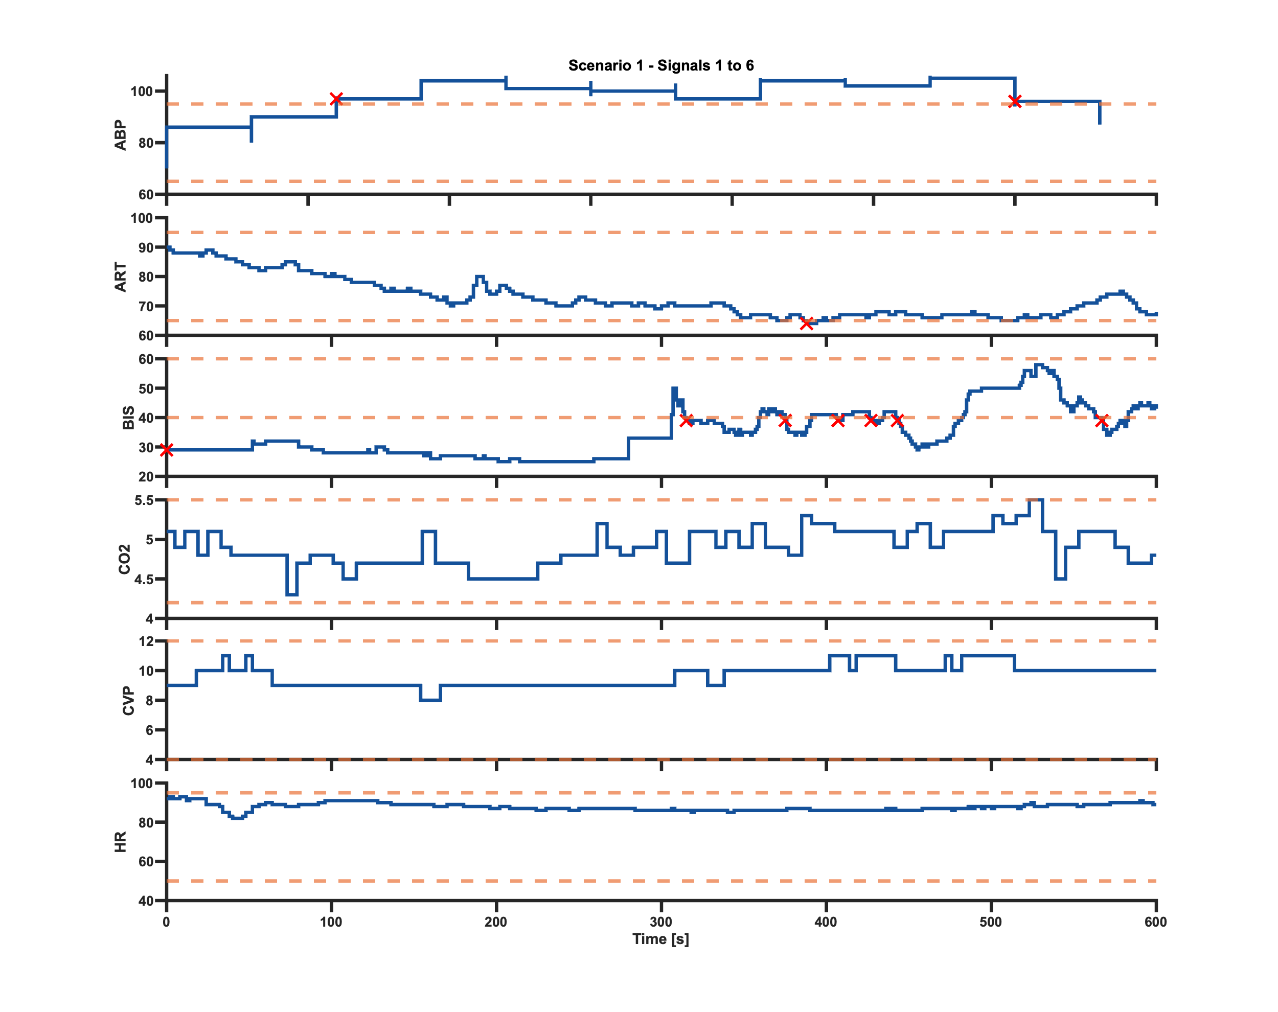
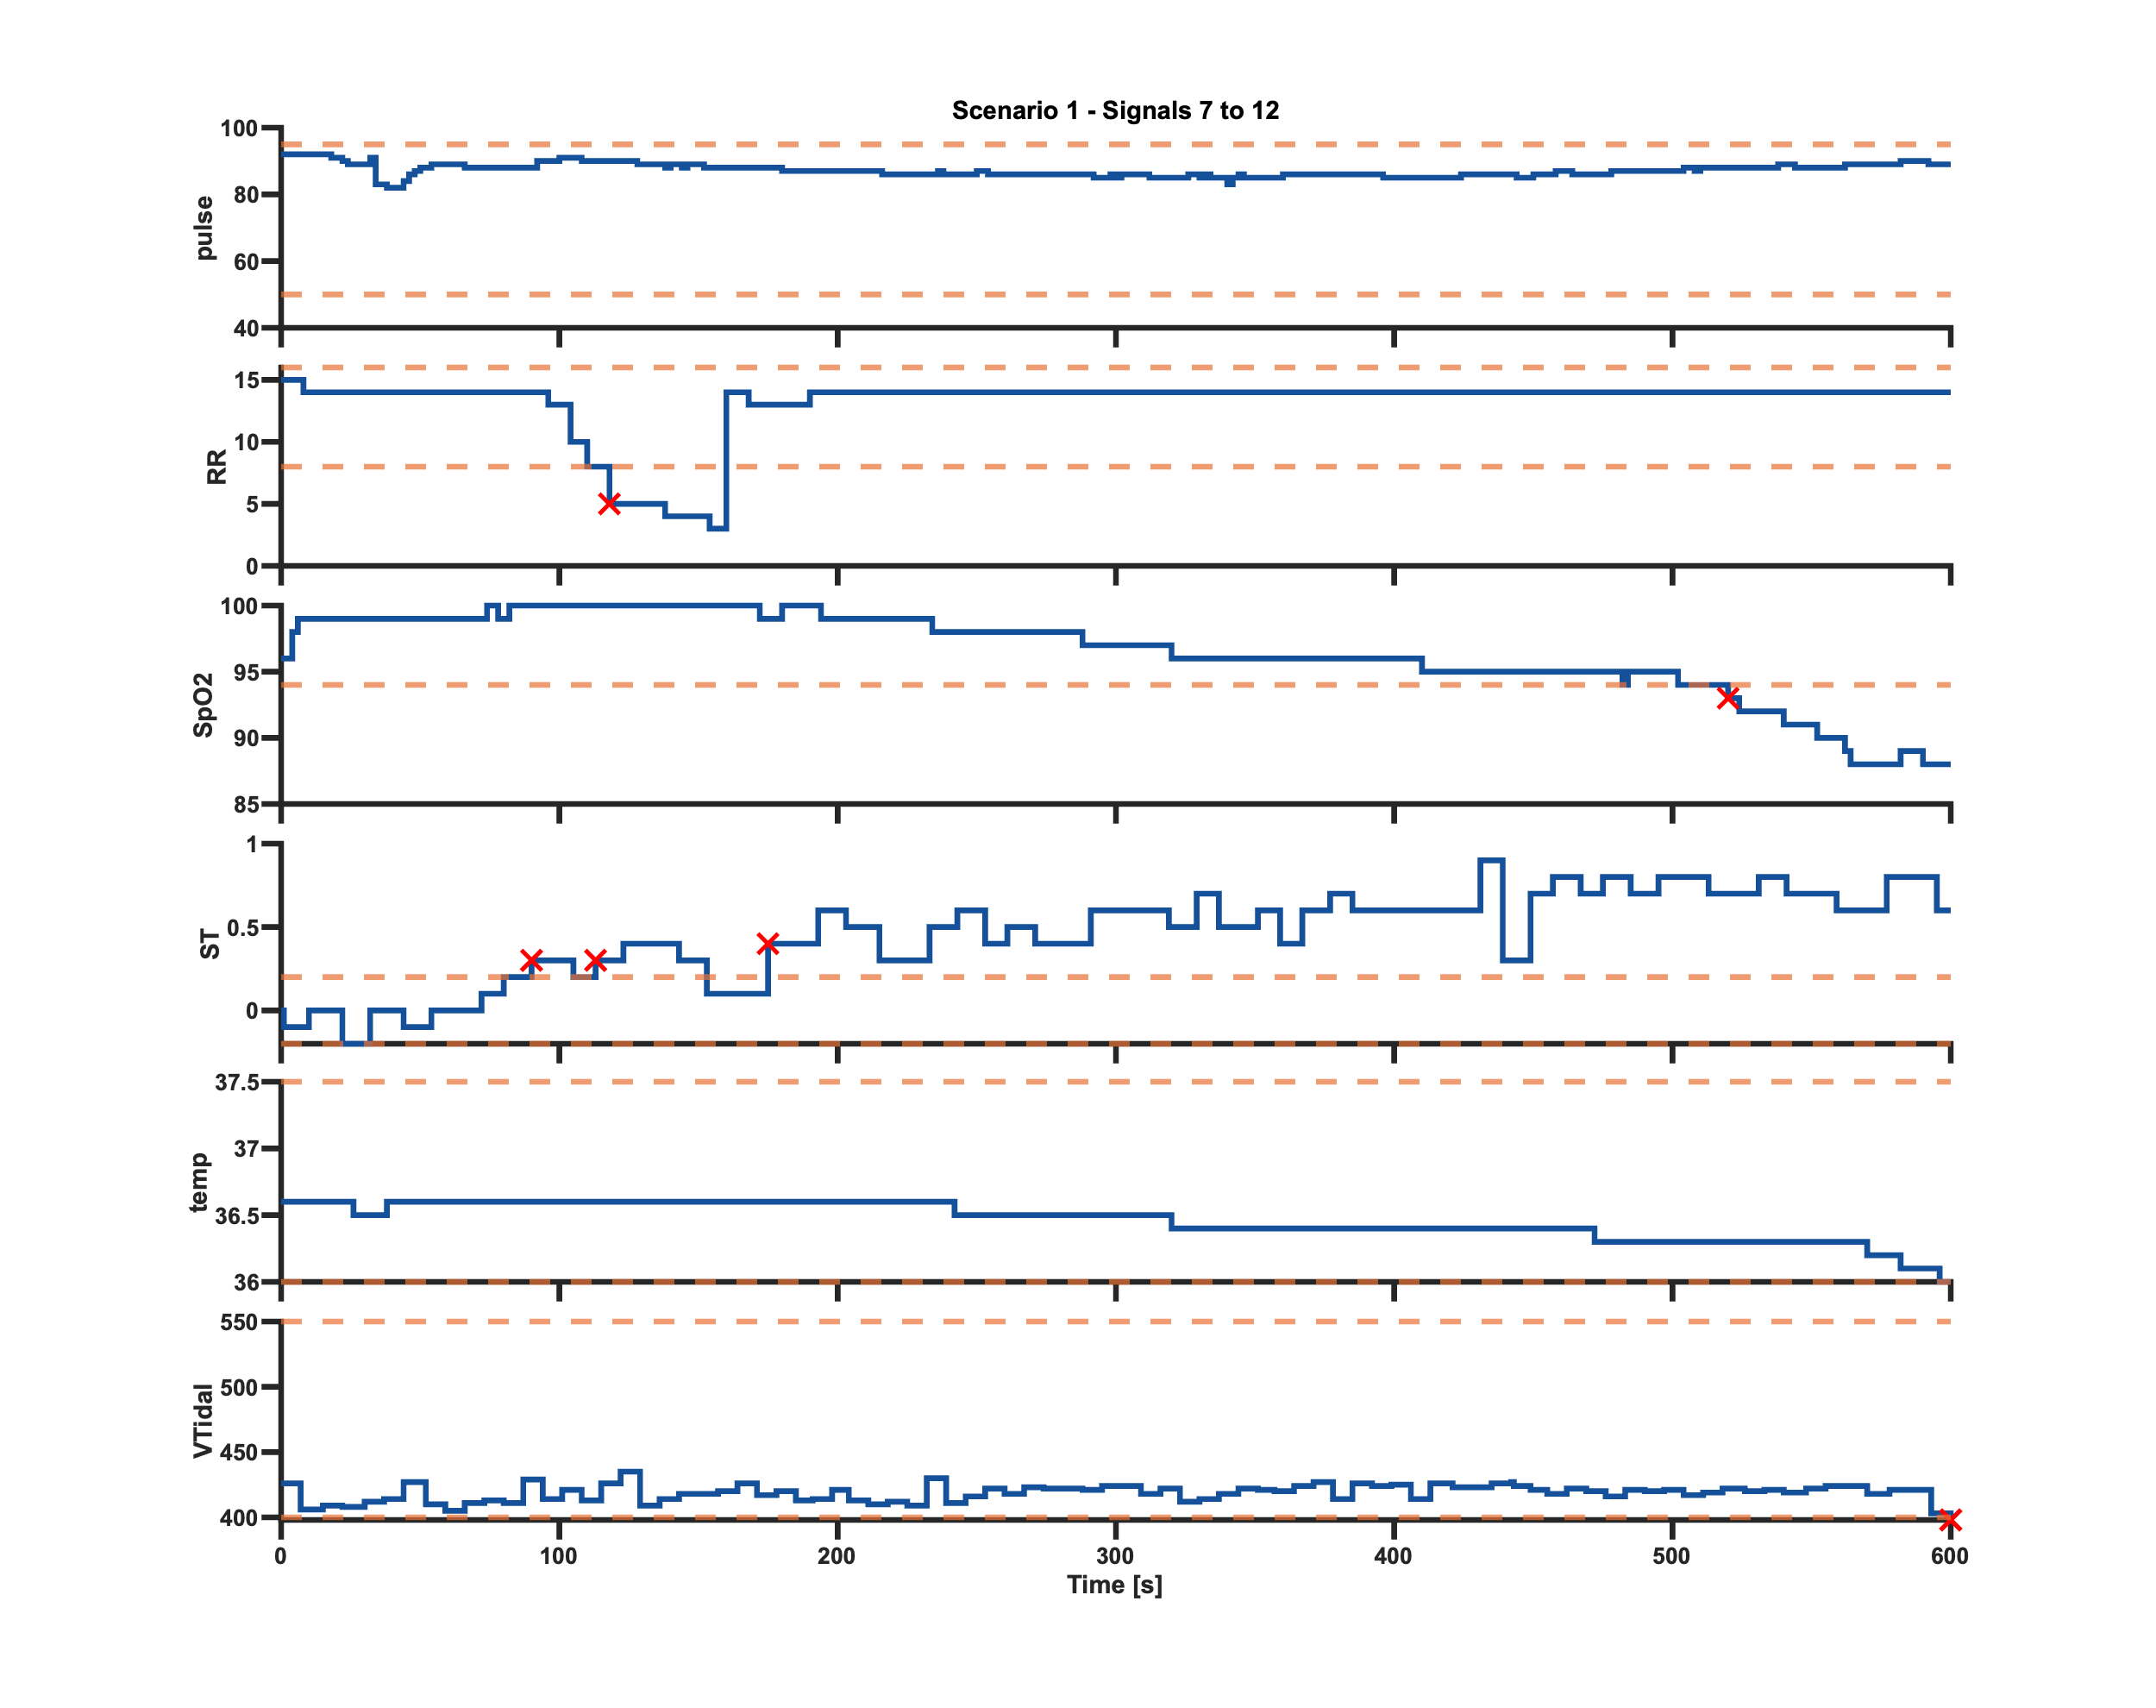
EVENT TIMELINE Scenario 2
Timestamp | Parameter | Direction |  | Legend
00:00:14 | HR | high |  | Event start
00:00:18 | PULSE | high |  | Event stop
00:00:19 | HR | aus |  | Prediction start
00:00:20 | HR | high |  | Prediction stop
00:01:14 | PULSE | normal
00:01:15 | HR | normal
00:01:20 | HR | high
00:01:22 | HR | normal
00:01:43 | MBP | high
00:01:44 | RR | low
00:01:48 | MBP | aus
00:01:49 | RR | aus
00:01:50 | RR | low
00:02:11 | MBP | high
00:02:12 | MBP | aus
00:02:12 | HR | high
00:02:13 | HR | aus
00:02:16 | HR | high
00:02:21 | HR | aus
00:02:37 | MBP | high
00:02:40 | RR | normal
00:02:50 | MBP | aus
00:02:51 | MBP | high
00:03:21 | CVP | low
00:03:30 | CVP | normal
00:03:39 | CVP | low
00:03:40 | etCO2 | high
00:03:42 | CVP | aus
00:03:47 | etCO2 | normal
00:03:54 | etCO2 | high
00:03:55 | etCO2 | aus
00:04:00 | etCO2 | high
00:04:07 | etCO2 | normal
00:04:20 | etCO2 | high
00:04:41 | etCO2 | normal
00:04:50 | etCO2 | high
00:04:59 | HR | high
00:05:22 | BT | high
00:05:51 | CVP | low
00:05:55 | CVP | normal
00:05:59 | CVP | low
00:06:02 | HR | aus
00:06:03 | CVP | normal
00:06:09 | CVP | low
00:06:26 | HR | high
00:06:30 | BIS | high
00:06:30 | BIS | aus
00:06:33 | CVP | normal
00:06:34 | BIS | high
00:06:35 | HR | aus
00:06:36 | TV | low
00:06:37 | BIS | aus
00:06:42 | TV | normal
00:06:43 | CVP | low
00:06:50 | SpO2 | low
00:06:55 | TV | low
00:06:58 | HR | high
00:07:11 | etCO2 | normal
00:07:20 | etCO2 | high
00:08:00 | TOF | low
00:08:21 | SpO2 | aus
00:08:22 | SpO2 | low
00:08:31 | etCO2 | normal
00:08:33 | CVP | normal
00:08:52 | etCO2 | high
00:08:55 | CVP | low
00:08:59 | etCO2 | normal
00:09:06 | BIS | high
00:09:06 | BIS | aus
00:09:07 | BIS | high
00:09:07 | BIS | normal
00:09:08 | TV | normal
00:09:09 | BIS | high
00:09:13 | BIS | aus
00:09:14 | BIS | high
00:09:14 | etCO2 | high
00:09:15 | TV | low
00:09:16 | BIS | normal
00:09:19 | etCO2 | normal
00:09:20 | TV | low
00:09:21 | TV | low
00:09:28 | etCO2 | high
00:10:04 | PULSE | high
00:10:05 | HR | aus
00:10:06 | HR | high
00:10:10 | PULSE | normal
00:10:12 | PULSE | high
00:10:16 | PULSE | normal
00:10:24 | PULSE | high
00:10:29 | CVP | normal
00:10:37 | CVP | low
00:10:44 | BIS | high
00:10:46 | BIS | aus
00:10:47 | MBP | normal
00:10:49 | MBP | high
00:10:59 | BIS | high
00:11:03 | MBP | normal
00:11:05 | MBP | high
00:11:10 | BIS | aus
00:11:11 | BIS | high
00:11:13 | BIS | normal
00:11:14 | BIS | high
00:11:17 | TV | normal
00:11:24 | TV | low
00:11:32 | BIS | aus
00:11:33 | BIS | high
00:11:35 | BIS | normal
00:11:38 | BT | normal
00:11:38 | TOF | normal
00:11:38 | SpO2 | normal
00:11:38 | HR | normal
00:11:38 | PULSE | high
00:11:38 | TV | low
00:11:38 | CVP | low
00:11:38 | AIBP | high
00:11:38 | NIBP | high
00:11:38 | etCO2 | normal

Raw vital sign data time series Scenario 2