Supplementary Information


Online Resource 1 Educational video providing a detailed demonstration of the Philips Visual Patient Avatar and its representation of individual parameters within and outside their normal ranges

May also be retrieved from the following link:
https://onedrive.live.com/?authkey=%21AO9AhzOXksfxHlE&cid=4CDC70FFF5992E39&id=4CDC70FFF5992E39%21267714&parId=4CDC70FFF5992E39%21274697&o=OneUp

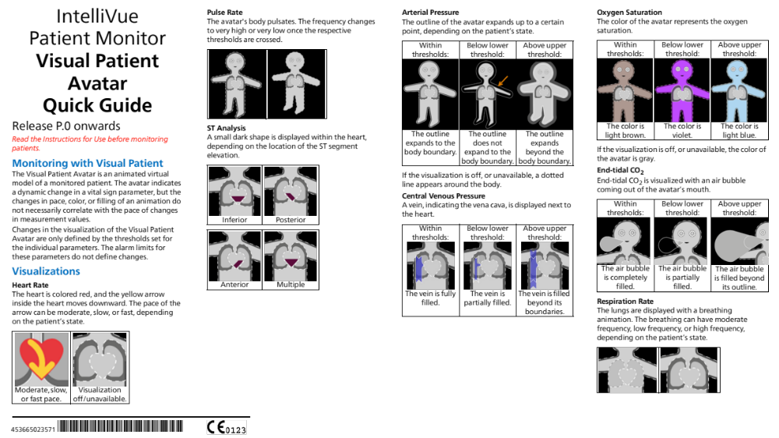
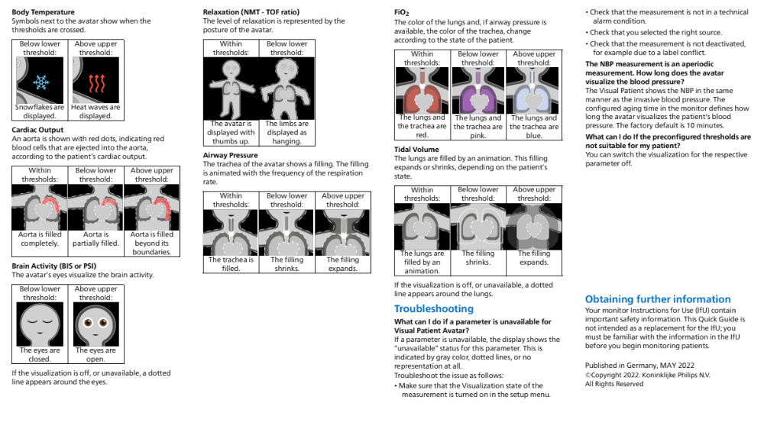
Online Resource 2 Short user guide to the Philips Visual Patient Avatar, available on the study centre’s intranet

Vital sign | Measuring unit | Range | Scenario 1 | Scenario 2
HR | min⁻¹ | 50-95 | 75 | 110
ST | mV | -0.2-0.2 | 0.0 | 4.5*
MAP | mmHg | 65-100 | 93 | 58
CVP | mmHg | 4-12 | 32 | 3
BIS | / | 40-60 | 75 | 45
TOF | % | < 80 | 95 | 0
SpO2 | % | < 94 | 85 | 99
RR | min⁻¹ | 12-16 | 12 | 22
TV | ml | 400-700 | 430 | 800
etCO2 | kPa | 4.2-5.5 | 5.1 | 3.3
T | °C | 36.5-37.4 | 34.9 | 36.8
Online Resource 3 2 Scenarios used in the simulation sessions
*ST Segment Elevation equals 4.5 mV in leads II, III, aVF
HR: heart rate; ST: ST segment; MAP: mean arterial pressure; CVP: central venous pressure; BIS: bispectral index; TOF: train-of-four ratio; SpO2: oxygen saturation; RR: respiratory rate; TV: tidal volume; etCO2: expiratory carbon dioxide concentration; T: body temperature; min⁻¹: per minute; mV: millivolt; mmHg: millimeter mercury; ml: milliliter; kPa: kilopascal; °C: degree Celsius

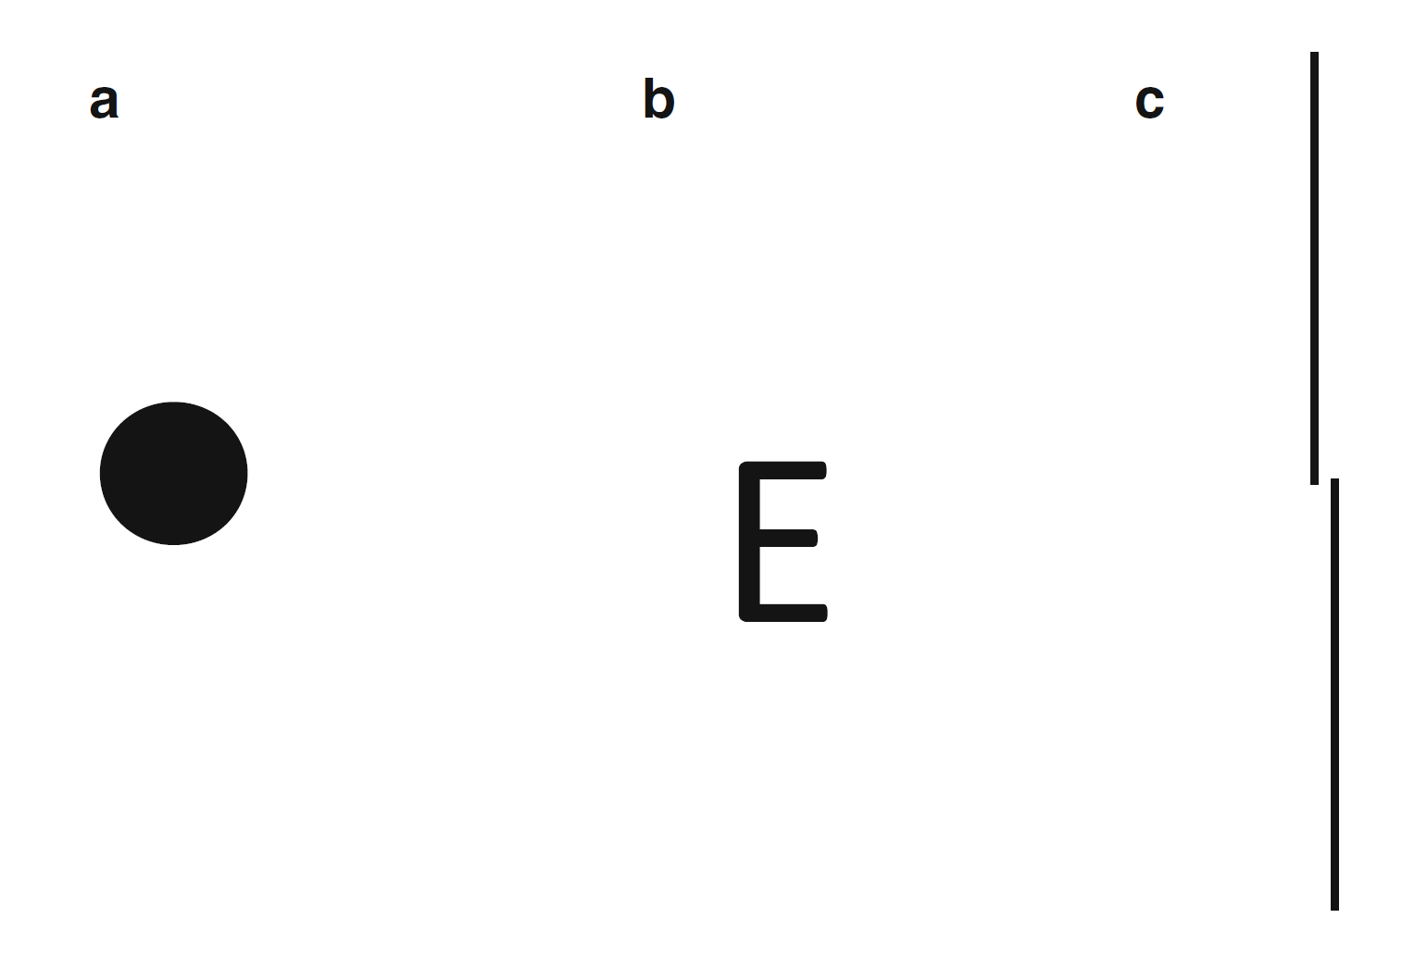
Online Resource 4 Schematic representation of different types of visual acuity: minimal visible – is there a dot? (a); minimal resolvable – is that an E or an F? (b); minimal discriminable visual acuity – is the upper line to the left or right of the lower line? (c). Adapted from [Skalicky, S. E.]. (2016). Ocular and Visual Physiology (p. 275). Springer Singapore

Heart rate | Minimum visible*
ST segment | Minimum visible
Mean arterial pressure | Minimum discriminable
Central venous pressure | Minimum discriminable
Bispectral index | Minimum visible
Train-of-four ratio | Minimum resolvable
Oxygen saturation | Minimum visible
Respiratory rate | Minimum visible*
Tidal Volume | Minimum discriminable
Expiratory carbon dioxide concentration | Minimum discriminable
Body temperature | Minimum visible

Online Resource 5 Pairing of the Philips Visual Patient Avatar vital sign visualizations with their appropriate type of visual acuity. We marked the pulse and respiratory rates as frequency-dependent vital signs (*)

