Supplementary material for manuscript:

Using an animated patient avatar to improve care providers’ perception of vital sign information.

Validation and calibration of the avatar.

To make this document easy to read, we placed the tables and figures at the end of the corresponding sections.

Table of contents

Detailed description of the avatar (Pages 2-6)

Purpose
Design characteristics
Initial design
Software prototype
Table 1
Figures 1-4

Iterative development of the avatar (Pages 7-23)

Introduction
Methods
Results
Discussion
Conclusion
Tables 2-9
Figure 5

Calibration of the avatar and Delphi process (Pages 24 and 25)

Introduction
Methods
Results
Discussion
Conclusion

References (Page 26)
Detailed description of the avatar

Purpose

The avatar’s intended purpose is to transmit the status of the vital signs to the care providers as quickly as possible and with minimal cognitive effort. Endsley et al. described this as the goal for a successful situation awareness technology.¹

Design characteristics

We drafted the initial version of the avatar and its visualisations based on principles of logic and user-centred design. Namely, the picture theory of representation from the Tractatus Logico-Philosophicus² by Ludwig Wittgenstein and principles of user-centred design from Designing for Situation Awareness¹ by Mica R. Endsley and Debra G. Jones.

According to Wittgenstein's theory, a picture is logical when it depicts a model of reality, i.e., it has a meaningful commonality with the reality it reflects. Likewise, principles of user-centred design recommend the use of direct representations of the phenomena that are causing the information, e.g. slowly breathing patient avatar vs a number indicating the respiratory rate, to facilitate the creation of situation awareness.

Consequently, in the avatar, the individual vital signs correspond to elements whose representation corresponds to the data measured in the patient in a meaningful way and are thereby linked with reality. For example, a too high pulse rate causes the body of the avatar to pulsate extremely fast. A too low oxygen saturation causes the skin of the avatar to become cyanotic. According to the monitored patient's medical condition, the avatar modifies its six elements. Modifications used are extension, expansion frequency, colour and geometric appearance of its elements and presence or absence of indicators.

Unlike conventional monitoring, which uses a single sensor, single indicator philosophy, i.e., vital signs are presented individually as waveforms or numbers³; the avatar integrates information about multiple vitals into visualisations in an animated model of the real patient (=a patient avatar), applying a multiple sensors, multiple indicators philosophy.

Furthermore, the avatar reduces the complexity of the vital sign data by processing it into 2 or 3 visualisation conditions. For vitals that can have a too low, safe, or too high status in the real patient, e.g., blood pressure, the avatar can display these three visualisation conditions. For vitals that can have an unsafe or safe status, e.g., oxygen saturation, the avatar can show these two conditions. Among all 11 vital signs, 30 different visualisation conditions can be displayed, giving the technology the theoretical capability of displaying a total of 4608 different situations.

Table 1, Figures 1-4 and Supplementary video 1 provide additional textual, graphical and audio-visual explanations of the avatar.

Initial design

We drafted an initial avatar design and involved human factor experts for initial feedback and further refinement. These human factor experts included pilots, psychologists, software developers and doctors. We used the resulting avatar version 1 in the first round of the iterative development process.

Software prototype

For this project, we developed an executable software prototype, which offered the ability to select, read and visualise various monitoring scenarios from Excel (Microsoft Corp., Redmond, WA, USA) documents. Employing the general-purpose programming language Java, we programmed software to animate a scalable vector graphic.
Table 1

Textual explanations of the visualisations of the avatar and their meaningful connections with the vital signs they represent. The elements of the avatar are explained graphically in Figures 1-4 and in audio-visual form in Supplementary Video 1. CO2=carbon dioxide.
Vital sign | Visualisation in the avatar | The phenomenon in the real patient after which we modelled the visualisation
1. Pulse rate | The pulsation frequency of the body (element #1) of the avatar.  Example: The avatar’s body pulsates with a slow, normal or quick frequency. | The pulse wave synchronous pulsation of the arteries, as visible, for example, under a microscope or palpable as a pulse.
2. Arterial blood pressure | The pulsation intensity of the body (element #1) of the avatar.  Example: The avatar’s body pulsates just barely, normally (i.e., reaching the white line designating the normal pulsation extension) or very intensely, extending far beyond the white “normal” line. | The strength of the pulse in the arteries depending on the arterial blood pressure, as visible, for example, under a microscope or palpable as a pulse.
3. Central venous pressure | The area of the vena cava (element #3) of the avatar  Example: The size of the avatar’s vena cava is very small, normal (i.e., reaching the white line designating the normal extension) or very large, far beyond the white “normal-line”. | The filling volume of the vena cava dependent on central venous pressure.
4. Respiratory rate | The breathing frequency of the lungs (element #4) of the avatar and the corresponding exhalation frequency of the CO2 cloud (element #5).  Example: The avatar’s lungs breathe with a slow, normal or high frequency and (if data from a CO2 sensor is available) synchronous slow, normal or quick exhalation of the CO2 cloud. | The breathing synchronous volume change of the lungs and the breathing synchronous, invisible exhalation of a volume of CO2.
5. Tidal volume | The extension size of the lungs (element #4) of the avatar during the breathing cycle.  Example: The avatar’s lungs extend just barely, normally (i.e., reaching the white line designating the normal breathing extension) or very far, noticeably beyond the white “normal-line”. | The volume change of the lungs depending on tidal volume.
6. Expiratory CO2 concentration | The extension size of the CO2 cloud (element #5) of the avatar during the breathing cycle.  Example: The CO2 cloud is just barely visible, reaches a normal extension (i.e., reaching the white line designating the normal breathing extension) or extends very wide, far beyond the white “normal” line. | The volume change of CO2 exhaled into the air.
7. Body temperature | The presence or absence of temperature indicators on the body (element #1) of the avatar.  Example: Heat waves are rising from the avatar, or ice crystals are visible on its skin. | Hyperthermia: The heat radiation from the skin.  Hypothermia: The skin cold to the touch.
8. Brain activity | The form of the eyes (element #6) of the avatar.  Example: The eyes of the avatar are open or closed. | High: Eyes open. Pupils middle wide, as in sympathetic activation.  Low: Eyelids completely closed, as in a sleeping patient.
9. Peripheral oxygen saturation | The colour of the body (element # 1) of the avatar.  Example: The avatar has a healthy skin colour or a purple skin colour. | Normal: light brown skin colour according to Fitzpatrick skin type III.  Hypoxia: dark purple skin colour as in cyanosis.
10. Neuromuscular function | The form of the body (element #1) of the avatar.  Example: The avatar has extended extremities and an extended thumb or the extremities appear floppy. | Normal neuromuscular function: Extended extremities and thumb (healthy muscle tone in the adductor policis muscle, where care providers frequently measure relaxation).  Neuromuscular block: floppy limbs.
11. Electrocardiography ST-Segment | The presence or absence of a hypoxia indicator over the heart (element #2) of the avatar.  Example: The heart muscle of the avatar has a homogenous vivid red colour or a dark purple colour. | Normal: the light red colour of healthy myocardium.  Hypoxia: the purple colour of hypoxic myocardium.

Figure 1

A schematic description of the avatar: The avatar is displayed with its head towards the bottom of the monitor to represent the habitual viewpoint of an anaesthesia provider during anaesthesia. The numbers 1 through 6 describe the elements of the avatar: #1: body, #2: heart, #3: vena cava, #4: lungs, #5: expiratory CO2 cloud, #6: eyes. The boxes and lines indicate the allocations of the vital signs to the elements of the avatar.
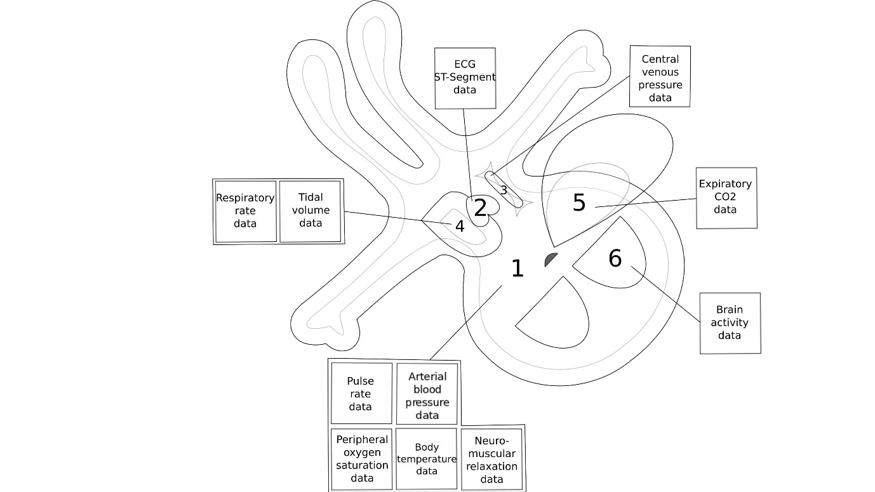

Figure 2

A screenshot of the avatar (version 3): The vital signs in this example correspond to the statuses described in the table to the left of the avatar. Pulse and respiratory rate are not visible in a still picture, as their assessment requires an animated avatar, as shown in Supplementary Video 1.

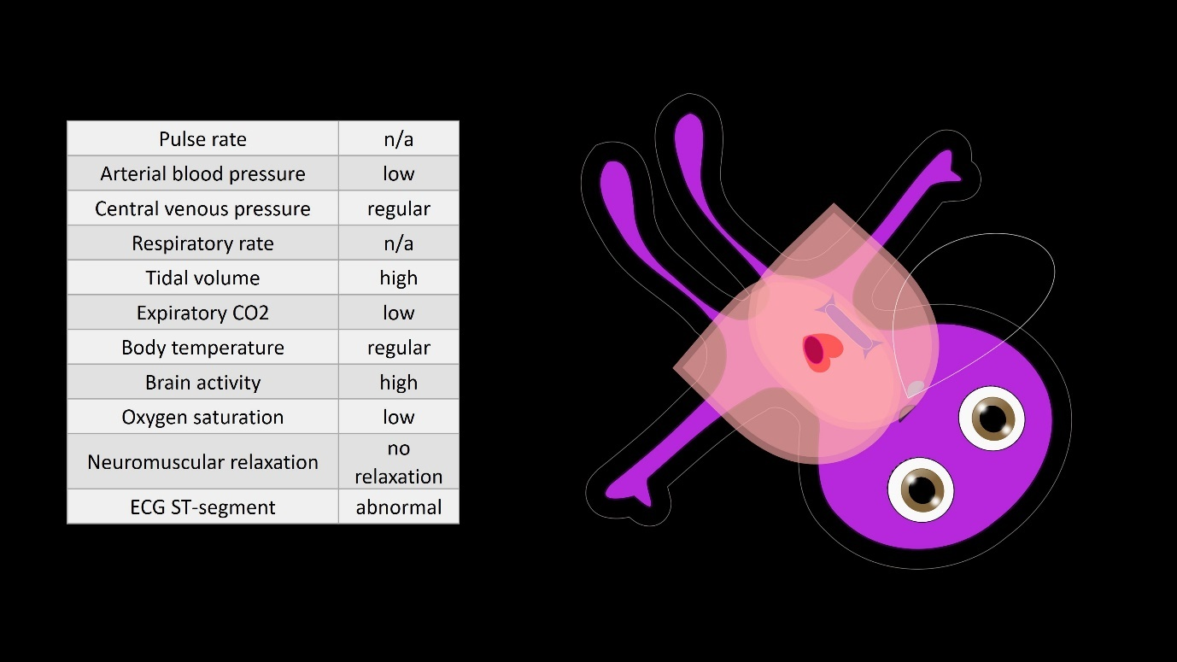
Figure 3

A screenshot of the avatar (version 3): The vital signs in this example correspond to the statuses described in the table to the left of the avatar. Pulse and respiratory rate are not visible in a still picture, as their assessment requires an animated avatar, as shown in Supplementary Video 1.

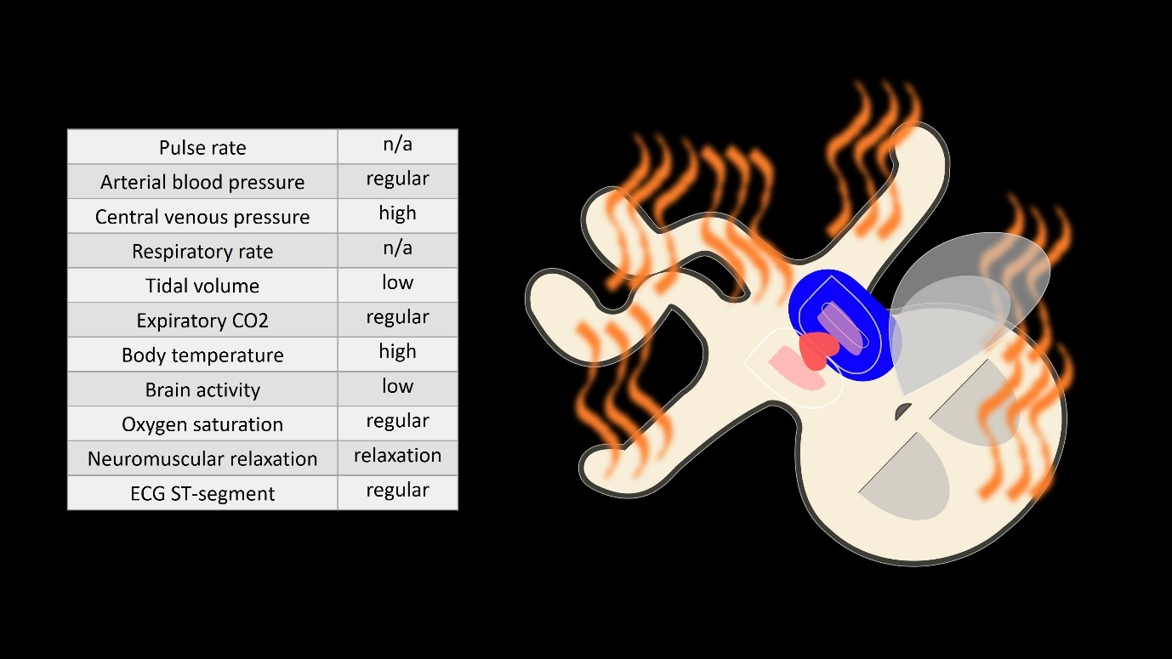

Figure 4

A screenshot of the avatar (version 3): The vital signs in this example correspond to the statuses described in the table to the left of the avatar. Pulse and respiratory rate are not visible in a still picture, as their assessment requires an animated avatar, as shown in Supplementary Video 1. This figure also highlights the design elements “white-” or “normal-line” and shadow, which we explain in detail in the section qualitative analysis on page 10 and in Supplementary video 1.

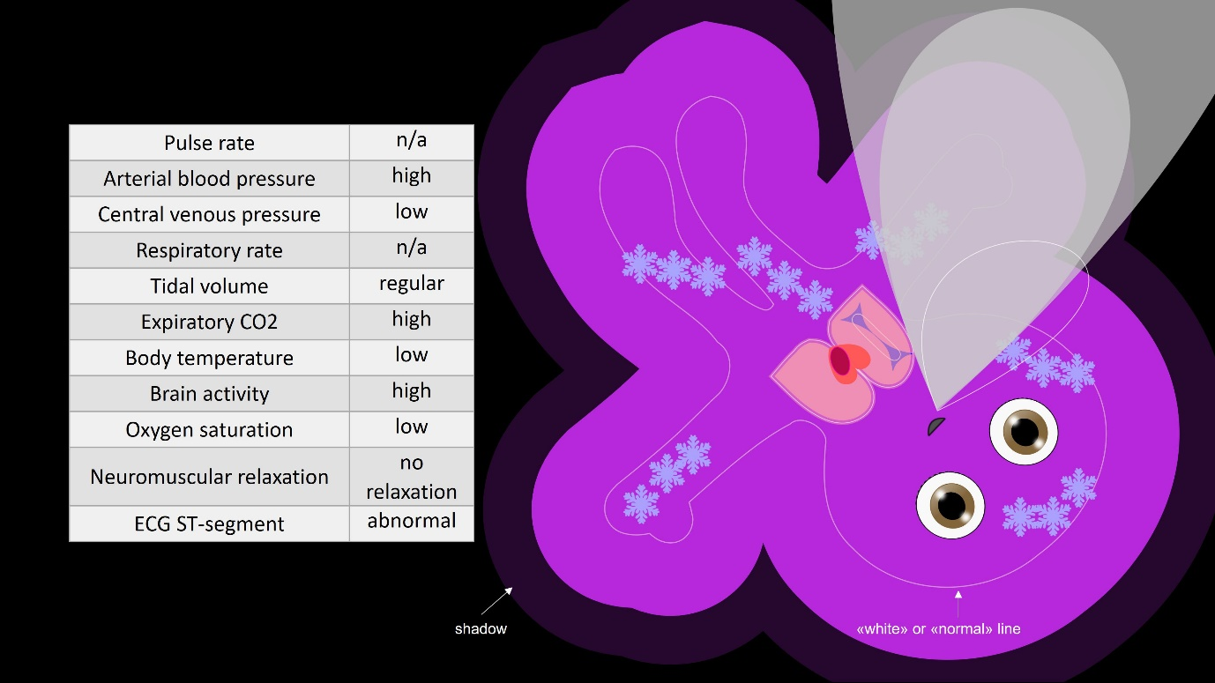
Iterative development of the avatar

Introduction

Before we could compare the newly developed animated patient avatar with conventional patient monitoring, we had to validate and calibrate it first.

We aimed to create a highly inter- and intra-rater-reliable avatar. Therefore, it was our goal to reach an inter-rater-reliability of > 90% for each of the avatar's 30 vital sign visualisations, i.e., the too low, safe and too high visualisations of all vitals.

To identify visualisation conditions with this desired specification and improve the avatar as necessary, we applied an iterative development process consisting of the evaluation of incremental versions of the avatar, followed by redesign and re-evaluation. For example, because blood pressure too low did not reach > 90% inter-rater-reliability in avatar version 1, we redesigned this visualisation and re-evaluated it in version 2, where it reached >90% inter-rater-reliability.

Methods

Study participants

The study participants were physicians (staff and resident anaesthesiologists) and nurse anaesthetists with a completed specialization qualification from the anaesthesia departments of the University Hospital of Zurich (USZ) and the Kantonsspital Winterthur (KSW) - two teaching hospitals in Switzerland performing approximately 30,000 and 10,000 surgical procedures per year, respectively.

Participation was voluntary and the participants received no compensation. We included anaesthesia experts who responded to institutional e-mail invitations and asked staff members to participate according to their availability.

Study design

To improve the avatar until all its 30 vital sign visualisations reached an inter-rater-reliability of > 90%, we conducted a multi-method laboratory study. The methods applied included the assessment of participants' perceptions of the vital sign visualisations in multiple VP scenarios featuring different visualisation conditions, e.g., various slower and quicker pulsation frequencies of the body of the avatar and the assessment of the participants' answers during an interview conducted after each data collection session.

Data were entered using an iPad- (Apple Inc., Cupertino, CA, USA) and iSurvey-based (Harvest Your Data, Wellington, New Zealand) data collection tool.⁴ The participants' interview answers were recorded in a Microsoft Word file.

Study procedure

Like in the primary study reported in the main manuscript, we collected the data with participants sitting in front of a laptop computer inside a quiet room in the two study centres; the only other person present was the data collector.

Before the data collection sessions, the participants completed a survey about personal information, e.g., age group, gender, previous experience with conventional monitors, etc. on the iPad and, as a standardized method of instruction, watched a 6-minute educational video explaining the visualisations of the avatar. We modified the educational video to fit each improved avatar version. Supplementary Video 1 corresponds to the video for the avatar used in the primary study, i.e., avatar version 3. This video and all others in this study were shown in ultra-high resolution (3840x2160 pixels) at 60 frames per second on the 15-inch screen of the laptop computer.

The data collector conducted the participant interviews at the end of the data collection session, still in the same room with only the participant and the data collector present.
Scenarios

Each participant was presented with 14 (avatar version 1), eight (version 2) and four (version 3) videos, respectively, in sequence. These videos showed only the avatar with modified vital sign visualisations and no other monitoring data. The scenarios were pre-recorded and played back as videos to enable equal study conditions for all participants. There were no time restrictions for the ratings. To avoid ordering and fatigue effects, we randomized the order in which the participants rated the visualisations and the position in which the videos were shown.

During the evaluation of avatar version 1, for some vital signs up to 11 different visualisation conditions were tested, e.g., 11 different pulsation frequencies for pulse rate. Tables 2 to 4 show the randomized assignment of the different visualisation conditions to the videos presented during the evaluations of the three avatar versions.

For the evaluation of intra-rater reliability, some videos were shown twice under different codenames during the same sessions, also randomized, so each of these videos was rated double an equal number of times. Three of the 14 (avatar version 1), two of the eight (version 2) and one of four (version 3) videos, respectively, were shown double.

Figure 5 provides a flowchart of the study design.

Outcome measures

Inter- and Intra-rater-reliability

To measure the inter-rater-reliability of every one of the avatar's 30 visualisation conditions, the participants were asked to rate how they perceived each visualisation after each video. The choices were three nominal scale-level measurement options: too low, safe or too high.

To assess the inter-rater-reliability of each visualisation condition, we analysed how many participants gave the same responses for each visualisation condition. To calculate the collective inter- and intra-rater-reliability of all visualisations of an avatar version taken together we calculated Fleiss’ Kappa.

The rationale for assessing inter and intra-rater-reliability was that it is an essential requirement for the usefulness of the technology. Users must be able to discern reliably, whether a vital sign is too low, safe, or too high.

Interactions

From the participants’ ratings, we assessed whether interactions between visualisations were present in the avatar versions.

The rationale for assessing the avatar for interactions was that absence of interactions is also a requirement for the usefulness of the technology. Users must be able to identify the visualisations correctly in any arbitrary combination of visualisations.

Statistics

We report inter-rater reliability for the individual visualisation conditions as the number of participants who gave the same opinion out of the total. To assess the collective inter- and intra-rater-reliability of the avatar, we calculated Fleiss Kappa with 95% bias-corrected bootstrap confidence intervals (CI) using the procedure "kapci" in Stata 13.1 (StataCorp. LCC, College Station, TX, USA).

To test for interactions between the visualisations, we calculated Pearson correlation coefficients between all visualisations. In the cases in which we found a correlation of r > 0.4, we determined partial Pearson correlation coefficients (r part) correcting for the actual visualisations in the scenarios. We did this because some scenarios contained inherent interactions despite the randomized distribution of the visualisations. We considered an r part > 0.2 a significant correlation.
We conducted a pilot study with 5 participants before the actual study, which revealed inter-rater-reliability values of at least 90% for all visualisations. For the avatar version 1, we decided to include at least 100 participants so that one percent would correlate to at least one actual participant.

Interview

After the rating of the last video was complete, participants answered the interview question: "What should we improve in the Visual Patient technology and how should these improvements look?"

The participants were invited to answer frankly with whatever comes to their minds and the data collector typed along as the participants responded. There were no time constraints and no prompts or guides were provided. The transcript of the interview was visible to the participants during data entry and was made available for comments and corrections afterwards.

Qualitative analysis

Two of the authors derived themes from the answers given by the participants using Atlas TI 8.0 software (Scientific Software Development GmbH, Berlin, Germany) for data management.

The rationale for evaluating the participants' interview answers qualitatively was to gain a comprehensive understanding of their opinions about the technology and receive improvement suggestions. Collecting qualitative user feedback has been suggested as a helpful adjunct to the collection of objective data for user-centred design development.¹

The ethics committee of the Canton of Zurich, Zurich, Switzerland reviewed the study protocol and concluded that ethics approval was not applicable because the study does not qualify as human subjects research (BASEC-Nr. Req-2016-00103). Still, all participants gave written informed consent.
Results

Study participants

Table 5 outlines the study and participant characteristics.

Outcome measures

Inter-rater-reliability

In the initial version of the avatar, 23 of the 30 total visualisation conditions yielded >90% inter-rater-reliability. In version 2, all 30 visualisation conditions yielded >90% inter-rater-reliability.
In the final version (version 3), one visualisation condition yielded 94%, four visualisation conditions yielded 97% and 25 of the 30 total visualisation conditions yielded 100% inter-rater-reliability.

The collective inter-rater-reliability of the avatar improved over the iterative versions from Fleiss’ kappa (95% CI) = 0.78 (0.70 - 0.86), in version 1, over kappa (95% CI) = 0.88 (0.80 – 0.94), in version 2 to kappa (95% CI) 0.98 (0.96–0.99, p<0.001) in the final version.

Tables 6-8 outline the inter-rater-reliabilities for each visualisation condition in avatar versions 1 through 3.

Intra-rater-reliability

Like the collective inter-rater-reliability, also the collective intra-rater-reliability of the avatar improved over the iterative versions from Fleiss’ kappa 0.79 (0.78 - 0.81), in version 1, over kappa (95% CI) = 0.87 (0.85 – 0.89), in version 2, to kappa (95% CI) 0.97 (0.93–0.99, p<0.001) in the final version.

Interactions

We did not detect interactions in any of the avatar versions.

Qualitative analysis

We analysed the participants' qualitative feedback and identified four themes: I: the colour of oxygen saturation too low, II: interactions between visualisations, III: differentiation between safe and unsafe states and IV: avatar design.

Based on these themes and the participants' suggestions, we implemented three derived design modifications in avatar version 3:

- We adapted the colour used to indicate oxygen saturation “too low”, which was initially a vivid blue to a purple colour. Some of the participants indicated that the vivid blue colour might influence them to think the patient is hypothermic.

We added a thin white line, which is always visible and designates the healthy state for all vital signs visualised by the extension of an element of the avatar, namely blood pressure, central venous pressure, tidal volume, expiratory CO2 and neuromuscular relaxation. We added this modification to avoid possible interpretation difficulties between the visualisation blood pressure too high, which increases the size of the avatar’s body and thereby may complicate the interpretation of other vital signs also visualised by the extension of an element, or visualised by geometric appearance. Remarkably, although stated by several participants, we did not find these perceived interactions reflected in the interaction analyses of their ratings. Despite this fact, we added the "normal-line" to simplify the interpretation and make the avatar more user-friendly.

- We implemented a shadow, which designates the maximum of the current extension of an element. We added this modification for all vital signs, which are visualised through the extension of an element to enable instant recognition, at any point during the pulsation- or breathing cycle. We based this on the reports from participants that a slow pulse increases the time required to recognise blood pressure and a slow respiratory frequency increases the time necessary to recognise tidal volume and expiratory CO2.

Table 9 outlines the results of the qualitative analysis of the participants' improvement suggestions and the solutions we derived from their recommendations and consequently implemented in the final version of the avatar. Figure 4 highlights the design elements “white” or “normal” line and shadow.

The combination of the objective measurements of the participants' perceptions and their qualitative feedback enabled us to create avatar version 3, which reached excellent inter-rater-reliability values and which we used in the comparative study with conventional monitoring.
Table 2

The randomised allocation of the visualisation conditions in the monitoring scenarios used for the evaluation of version 1 of the avatar. For example, in scenario 1, the participants rated the visualisation conditions of an avatar pulsating at 290 beats per minute whose body (=element #1) reached a maximum area of 156.6 cm², etc. For the evaluation of avatar version 1, 108 participants rated 14 scenarios. To assess intra-rater-reliability, per participant, we showed three random scenarios twice under a different codename. CO2=carbon dioxide, cm²=square centimetres.

 | 1. Pulse rate  (Extension frequency of element #1 (body]  min-1) | 2. Arterial blood pressure  (Extension of element #1 [body] in cm²) | 3. Central venous pressure  (Extension of element #3 [vena cava] in cm²) | 4. Respiratory rate  (Extension frequency of element #4 [lungs] min-1) | 5. Tidal volume  (Extension of element #4 [lungs] in cm²) | 6. Expiratory CO2 concentration  (Extension of element #5 [CO2 cloud] in cm2) | 7. Body temperature  (Presence of temperature indicators on element #1 [body]) | 8. Brain activity  (Form of element #6 [eyes]) | 9. Peripheral oxygen saturation  (Colour of element #1 [body]) | 10. ECG ST-Segment  (Presence of ST-segment deviation indicator on element #2 [heart]) | 11. Neuromuscular relaxation  (Form of element #1 [body])
Scenario 1 | 290 | 156.6 | 1.0 | 103 | 15.6 | 184.7 | 18 icicles | closed | purple skin | absent | relaxed
Scenario 2 | 315 | 528.4 | 2.4 | 50 | 8.2 | 0.1 | 18 heatwaves | intermediate | purple skin | absent | no relaxation
Scenario 3 | 295 | 225.5 | 3.4 | 99 | 17.8 | 0.0 | 6 icicles | open | normal skin colour | present | relaxed
Scenario 4 | 21 | 540.1 | 0.5 | 84 | 2.3 | 192.3 | 6 heatwaves | closed | purple skin | present | no relaxation
Scenario 5 | 260 | 494.4 | 3.5 | 0.0 | 2.1 | 0.0 | 2 icicles | intermediate | normal skin colour | absent | relaxed
Scenario 6 | 32 | 432.6 | 1.7 | 1 | 17.1 | 48.3 | 2 heatwaves | open | purple skin | absent | no relaxation
Scenario 7 | 3 | 309.8 | 0.4 | 92 | 12.5 | 2.8 | no temperature indicators | closed | normal skin colour | present | relaxed
Scenario 8 | 140 | 109.3 | 3.1 | 4 | 2.2 | 149.0 | 18 icicles | intermediate | purple skin | present | no relaxation
Scenario 9 | 236 | 542.9 | 0.3 | 12 | 3.2 | 13.0 | 18 heatwaves | open | normal skin colour | absent | relaxed
Scenario 10 | 0 | 108.0 | 3.3 | 98 | 4.8 | 111.1 | 6 icicles | closed | purple skin | absent | no relaxation
Scenario 11 | 78 | 122.2 | 0.3 | 27 | 18.7 | 192.3 | 6 heatwaves | intermediate | purple skin | present | relaxed

Table 3

The randomised allocation of the visualisation conditions in the monitoring scenarios used for the evaluation of version 2 of the avatar. For example, in scenario 1, the participants rated an avatar pulsating at 156 beats per minute whose body (=element #1) reached a maximum area of 162.7 cm², etc. For the evaluation of avatar version 2, 50 participants rated eight scenarios. To assess intra-rater-reliability, per participant, we showed two random scenarios twice under a different codename. CO2=carbon dioxide, cm²=square centimetres.

 | 1. Pulse rate  (Extension frequency of element #1 (body]  min-1) | 2. Arterial blood pressure  (Extension of element #1 [body] in cm²) | 3. Central venous pressure  (Extension of element #3 [vena cava] in cm²) | 4. Respiratory rate  (Extension frequency of element #4 [lungs] min-1) | 5. Tidal volume  (Extension of element #4 [lungs] in cm²) | 6. Expiratory CO2 concentration  (Extension of element #5 [CO2 cloud] in cm²) | 7. Body temperature  (Presence of temperature indicators on element #1 [body]) | 8. Brain activity  (Form of element #6 [eyes]) | 9. Peripheral oxygen saturation  (Colour of element #1 [body]) | 10. ECG ST-Segment  (Presence of ST-segment deviation indicator on element #2 [heart]) | 11. Neuromuscular relaxation  (Form of element #1 [body])
Scenario 1 | 156 | 162.7 | 10.7 | 150 | 2.2 | 392.9 | no temperature indicators | closed | normal skin colour | present | no relaxation
Scenario 2 | 280 | 97.7 | 0.0 | 29 | 6.4 | 10.9 | 18 icicles | intermediate | purple skin | present | relaxed
Scenario 3 | 0 | 92.1 | 1.3 | 23 | 8.3 | 0.2 | 18 icicles | closed | normal skin colour | Absent | relaxed
Scenario 4 | 156 | 500.1 | 7.8 | 225 | 40.8 | 10.9 | 18 heatwaves | closed | purple skin | Absent | no relaxation
Scenario 5 | 4 | 162.7 | 4.1 | 0 | 2.1 | 0.0 | 18 heatwaves | intermediate | normal skin colour | absent | no relaxation
Scenario 6 | 380 | 92.1 | 0.2 | 3 | 31.2 | 286.9 | no temperature indicators | open | purple skin | present | relaxed

Table 4

The randomised allocation of the visualisation conditions in the monitoring scenarios used for the evaluation of avatar version 3. For example, in scenario 1, the participants rated an avatar pulsating at 380 beats per minute whose body (element #1) reached a maximum area of 114.5 cm2, etc. For the evaluation of avatar version 3, 32 participants rated four scenarios. To assess intra-rater-reliability, per participant, we showed one random scenario twice under a different codename. CO2=carbon dioxide, cm2=square centimetres.

 | 1. Pulse rate  (Extension frequency of element #1 (body]  min-1) | 2. Arterial blood pressure  (Extension of element #1 [body] in cm²) | 3. Central venous pressure  (Extension of element #3 [vena cava] in cm²) | 4. Respiratory rate  (Extension frequency of element #4 [lungs] min-1) | 5. Tidal volume  (Extension of element #4 [lungs] in cm²) | 6. Expiratory CO2 concentration  (Extension of element #5 [CO2 cloud] in cm²) | 7. Body temperature  (Presence of temperature indicators on element #1 [body]) | 8. Brain activity  (Form of element #6 [eyes]) | 9. Peripheral oxygen saturation  (Colour of element #1 [body]) | 10. ECG ST-Segment  (Presence of ST-segment deviation indicator on element #2 [heart]) | 11. Neuromuscular relaxation  (Form of element #1 [body])
Scenario 1 | 380 | 114.5 | 1.7 | 27 | 40.8 | 10.9 | 18 heatwaves | closed | normal skin colour | present | relaxed
Scenario 2 | 4 | 586.2 | 0.0 | 225 | 4.8 | 392.9 | 18 icicles | open | purple skin | present | no relaxation
Scenario 3 | 78 | 225.5 | 10.7 | 3 | 2.1 | 0.0 | no temperature indicators | intermediate | purple skin | absent | relaxed

Table 5

The characteristics of the participants and development cycles. IQR=Interquartile range. VP naïve participants=participants who had no previous
 | Avatar version 1 | Avatar version 2 | Avatar version 3 | Total
Duration of study in days | 106 | 53 | 41 | 200
Number of VP naïve participants (%)  in development step | 108 (100%) | 27 (54%) | 15 (47%) | 150 (79%)
Total number of participants in development step | 108 | 50 | 32 | 190
Number of senior staff members and staff members (%) | 34 (32%) | 15 (30%) | 12 (37%) | 61 (32%)
Number of residents (%) | 37 (34%) | 20 (40%) | 8 (25%) | 65 (34%)
Number of nurse anaesthetists (%) | 37 (34%) | 15 (30%) | 12 (38%) | 64 (34%)
Number of male/female participants (%) | 57 (59%) / 51 (41%) | 25 (50%) / 25 (50%) | 15 (47%) / 17 (53%) | 97 (51%) / 93 (49%)
Median (IQR) age group of participants in years | 35 to 44 (25 to 34 –  35 to 44) | 35 to 44 (25 to 34 –  35 to 44) | 35 to 44 (25 to 34 –  45 to 54) | 35 to 44 (25 to 34 –  35 to 44)
Median (IQR) anaesthesia experience group of participants in years | 5 to 10  (1 to 5 – more than 10) | 5 to 10  (1 to 5 – more than 10) | 5 to 10  (1 to 5 – more than 10) | 5 to 10  (1 to 5 – more than 10)
Median (IQR) experience with  conventional patient monitors from different monitoring manufacturers | 2 (1 - 3) | 2 (1 - 3) | 2 (1 - 3) | 2 (1 - 3)
Median (IQR) duration of data collection session in minutes | 39 (36 – 45) | 27 (22 - 35) | 33 (30 - 39) | 36 (28 - 39)
contact with the avatar during the preceding cycles of the iterative development process.

Table 6

The inter-rater reliability of all visualisation conditions of version 1 of the patient avatar. One hundred and eight participants rated how they perceived different visualisation conditions of the 11 vital signs in the avatar. The visualisation conditions with >90% inter-rater-reliability are shadowed in dark grey. CO2=carbon dioxide, cm²=square centimetres.

1. Pulse rate  (extension of element #1 (body]  min-1) | 0 | 3 | 21 | 32 | 78 | 140 | 236 | 260 | 290 | 295 | 315
too low | 101/108 | 97/108 | 69/108 | 13/108 | 3/108 | 1/108 | 0/108 | 0/108 | 0/108 | 0/108 | 0/108
safe | 6/108 | 11/108 | 39/108 | 94/108 | 103/108 | 80/108 | 12/108 | 16/108 | 25/108 | 17/108 | 10/108
too high | 1/108 | 0/108 | 0/108 | 1/108 | 2/108 | 27/108 | 96/108 | 92/108 | 83/108 | 91/108 | 98/108
2. Arterial blood pressure  (extension of element #1 [body] in cm2) | 108.0 | 109.3 | 122.2 | 156.6 | 225.5 | 309.8 | 432.6 | 494.4 | 528.4 | 540.1 | 542.9
too low | 86/108 | 82/108 | 33/108 | 26/108 | 0/108 | 0/108 | 1/108 | 0/108 | 0/108 | 0/108 | 0/108
safe | 21/108 | 26/108 | 75/108 | 80/108 | 105/108 | 71/108 | 21/108 | 28/108 | 24/108 | 14/108 | 7/108
too high | 1/108 | 0/108 | 0/108 | 2/108 | 3/108 | 37/108 | 86/108 | 80/108 | 84/108 | 94/108 | 101/108
3. Central venous pressure  (extension of element #3 [vena cava] in cm2) | 0.3 | 0.3 | 0.4 | 0.5 | 1.0 | 1.7 | 2.4 | 3.1 | 3.3 | 3.4 | 3.5
too low | 47/108 | 20/108 | 49/108 | 29/108 | 14/108 | 1/108 | 0/108 | 0/108 | 0/108 | 0/108 | 0/108
safe | 61/108 | 88/108 | 59/108 | 79/108 | 94/108 | 106/108 | 63/108 | 31/108 | 22/108 | 24/108 | 20/108
too high | 0/108 | 0/108 | 0/108 | 0/108 | 0/108 | 1/108 | 45/108 | 77/108 | 86/108 | 84/108 | 88/108
4. Respiratory rate  (extension frequency of element #4 [lungs] min-1) | 0.0 | 1 | 4 | 12 | 27 | 50 | 84 | 92 | 98 | 99 | 103
too low | 98/108 | 87/108 | 81/108 | 67/108 | 1/108 | 6/108 | 3/108 | 0/108 | 15/108 | 1/108 | 0/108
safe | 10/108 | 20/108 | 25/108 | 41/108 | 105/108 | 101/108 | 95/108 | 68/108 | 71/108 | 80/108 | 55/108
too high | 0/108 | 1/108 | 2/108 | 0/108 | 2/108 | 1/108 | 11/108 | 40/108 | 22/108 | 27/108 | 53/108
5. Tidal volume  (extension of element #4 [lungs] in cm2) | 2.1 | 2.2 | 2.3 | 3.2 | 4.8 | 8.2 | 12.5 | 15.6 | 17.1 | 17.8 | 18.7
too low | 101/108 | 97/108 | 90/108 | 43/108 | 2/108 | 3/108 | 5/108 | 0/108 | 0/108 | 4/108 | 0/108
safe | 5/108 | 11/108 | 18/108 | 64/108 | 103/108 | 83/108 | 45/108 | 51/108 | 37/108 | 39/108 | 31/108
too high | 2/108 | 0/108 | 0/108 | 1/108 | 3/108 | 22/108 | 58/108 | 57/108 | 71/108 | 65/108 | 77/108
6. Expiratory CO2 concentration  (extension of element #5 [CO2 cloud] in cm2) | 0.0 | 0.0 | 0.1 | 2.8 | 13.0 | 48.3 | 111.1 | 149.0 | 184.7 | 192.3 | 192.3
too low | 105/108 | 104/108 | 104/108 | 53/108 | 15/108 | 1/108 | 1/108 | 3/108 | 2/108 | 0/108 | 1/108
safe | 3/108 | 4/108 | 3/108 | 55/108 | 93/108 | 92/108 | 53/108 | 23/108 | 16/108 | 15/108 | 14/108
too high | 0/108 | 0/108 | 1/108 | 0/108 | 0/108 | 15/108 | 54/108 | 82/108 | 90/108 | 93/108 | 93/108

Table 6 (continued)

7. Body temperature  (Presence of temperature indicators on element #1 [body]) | 18 icicles | 6 icicles | 2 icicles | 0 | 2 heatwaves | 6 heatwaves | 18 heatwaves
too low | 106/108 | 103/108 | 69/108 | 0/108 | 0/108 | 1/108 | 0/108
safe | 0/108 | 4/108 | 39/108 | 108/108 | 32/108 | 5/108 | 1/108
too high | 2/108 | 1/108 | 0/108 | 0/108 | 76/108 | 102/108 | 107/108
8. Brain activity  (Form of element #6 [eyes]) | eyes closed | eyes intermediate | eyes open
low | 108/108 | 0/108 | 1/108
intermediate | 0/108 | 107/108 | 1/108
high | 0/108 | 1/108 | 106/108
9. Peripheral oxygen saturation  (Colour of element #1 [body]) | Purple skin | Safe skin colour
too low | 107/108 | 2/108
safe | 1/108 | 106/108
10. ECG ST-Segment  (Presence of ST-segment deviation indicator on element #2 [heart]) | Myocardial hypoxia indicator present | Myocardial hypoxia indicator absent
abnormal | 107/108 | 1/108
safe | 1/108 | 107/108
11. Neuromuscular relaxation  (Form of element #1 [body]) | Relaxed body | Safe body
relaxed | 104/108 | 105/108
no relaxation | 4/108 | 3/108

Table 7

The inter-rater reliability of all visualisation conditions of version 2 of the patient avatar. Fifty participants rated how they perceived different visualisation conditions of the 11 vital signs in the avatar. The visualisation conditions with >90% inter-rater-reliability are shadowed in dark grey. CO2=carbon dioxide, cm²=square centimetres.

1. Pulse rate  (extension of element #1 (body]  min-1) | 0 | 4 | 156 | 156 | 280 | 380
too low | 50/50 | 50/50 | 1/50 | 0/50 | 19/50 | 3/50
safe | 0/50 | 0/50 | 34/50 | 33/50 | 0/50 | 0/50
too high | 0/50 | 0/50 | 15/50 | 17/50 | 31/50 | 47/50
2. Arterial blood pressure  (extension of element #1 [body] in cm2) | 107.9 | 108.0 | 114.5 | 190.7 | 190.7 | 586.2
too low | 47/50 | 47/50 | 48/50 | 0/50 | 14/50 | 1/50
safe | 2/50 | 3/50 | 2/50 | 49/50 | 35/50 | 1/50
too high | 1/50 | 0/50 | 0/50 | 1/50 | 1/50 | 48/50
3. Central venous pressure  (extension of element #3 [vena cava] in cm2) | 0.0 | 0.2 | 1.1 | 3.5 | 6.6 | 9.1
too low | 48/50 | 47/50 | 10/50 | 1/50 | 2/50 | 0/50
safe | 2/50 | 2/50 | 39/50 | 0/50 | 0/50 | 1/50
too high | 0/50 | 1/50 | 1/50 | 49/50 | 48/50 | 49/50
4. Respiratory rate  (extension frequency of element #4 [lungs] min-1) | 0.0 | 3 | 23 | 29 | 150 | 225
too low | 50/50 | 50/50 | 17/50 | 6/50 | 1/50 | 0/50
safe | 0/50 | 0/50 | 26/50 | 40/50 | 0/50 | 0/50
too high | 0/50 | 0/50 | 7/50 | 4/50 | 49/50 | 50/50
5. Tidal volume  (extension of element #4 [lungs] in cm2) | 1.8 | 1.9 | 5.5 | 7.0 | 26.6 | 34.8
too low | 50/50 | 48/50 | 18/50 | 1/50 | 3/50 | 3/50
safe | 0/50 | 2/50 | 29/50 | 47/50 | 0/50 | 0/50
too high | 0/50 | 0/50 | 3/50 | 2/50 | 47/50 | 47/50
6. Expiratory CO2 concentration  (extension of element #5 [CO2 cloud] in cm2) | 0.0 | 0.2 | 9.3 | 9.3 | 244.8 | 335.1
too low | 50/50 | 48/50 | 2/50 | 2/50 | 2/50 | 0/50
safe | 0/50 | 2/50 | 48/50 | 47/50 | 0/50 | 0/50
too high | 0/50 | 0/50 | 0/50 | 1/50 | 48/50 | 50/50

Table 7 (continued)

7. Body temperature  (presence of temperature indicators on element #1 [body]) | 18 icicles | 0 | 18 heatwaves
too low | 49/50 | 1/50 | 0/50
safe | 1/50 | 49/50 | 0/50
too high | 0/50 | 0/50 | 49/50
8. Brain activity  (Form of element #6 [eyes]) | eyes closed | eyes intermediate | eyes open
low | 49/50 | 3/50 | 1/50
intermediate | 0/50 | 46/50 | 0/50
high | 1/50 | 1/50 | 49/50
9. Peripheral oxygen saturation  (colour of element #1 [body]) | Purple skin | Safe skin colour
too low | 49/50 | 1/50
safe | 1/50 | 49/50
10. ECG ST-Segment  (presence of ST-segment deviation indicator on element #2 [heart]) | Myocardial hypoxia indicator present | Myocardial hypoxia indicator absent
abnormal | 48/50 | 1/50
safe | 2/50 | 49/50
11. Neuromuscular relaxation  (Form of element #1 [body]) | Relaxed body | Safe body
relaxed | 48/50 | 1/50
no relaxation | 2/50 | 49/50

Table 8

The inter-rater reliability of all visualisation conditions of the final version of the patient avatar (=version 3) and the respective numerical vital sign values allocated to the visualisation conditions in a Delphi process. For example, when the input pulse-rate of a patient is below 45 beats per minute, as defined in the Delphi process, the body of the patient avatar (=element #1) pulsates with a frequency of four per minute. This pulsation frequency was perceived as “too low” by 32 of 32 participants.
Abbreviations: CO2=carbon dioxide, cm²=square centimetres, mmHg=millimeters of mercury, ml=milliliter, kPa=kilopascal. BIS=bispectral index system, SpO2=peripheral oxygen saturation, mV=millivolt, TOF=train of four.
Vital sign | Description of visualisation | too low | safe | too high
1. Pulse rate | Frequency of form change (min-1) of the avatar’s body (element #1)  Inter-rater-reliability | 4  32/32 (100%) | 78  31/32 (97%) | 380  32/32 (100%)
Range defined in Delphi process (Pulse frequency min-1) |  | <45 | 45 - 100 | >100
2. Arterial blood pressure | Extension (in cm²) of the avatar’s body (element #1)  Inter-rater-reliability | 114.5  32/32 (100%) | 225.5  31/32 (97%) | 586.2  31/32 (97%)
Range defined in Delphi process (Mean arterial blood pressure in mmHg) |  | <60 | 60 - 100 | >100
3. Central venous pressure | Extension (in cm²) of the avatar’s vena cava (element #3)  Inter-rater-reliability | 0  32/32 (100%) | 1.7  32/32 (100%) | 10.7  32/32 (100%)
Range defined in Delphi process (Central venous pressure in mmHg) |  | <2 | 2 - 14 | >14
4. Respiratory rate | Frequency of form change (min-1) of the avatar’s lungs (element #4)  Inter-rater-reliability | 3  32/32 (100%) | 27  32/32 (100%) | 225  32/32 (100%)
Range defined in Delphi process (Respiratory rate min-1) |  | <8 | 8 – 20 | >20
5. Tidal volume | Extension (in cm²) of the avatar’s lungs (element #4)  Inter-rater-reliability | 1.8  32/32 (100%) | 4.8  30/32 (94%) | 40.8  31/32 (100%)
Range defined in Delphi process (Tidal volume in ml) |  | <400 | 400 – 650 | >650
6. Expiratory CO2 concentration | Extension (in cm²) of the CO2 cloud (element #5)  Inter-rater-reliability | 0.05  31/32 (97%) | 9.3  32/32 (100%) | 392.4  32/32 (100%)
Range defined in Delphi process (Expiratory CO2 in kPa) |  | <4.2 | 4.2 – 5.5 | >5.5
7. Body temperature | Number of temperature indicators present on the avatar’s body (element #1)  Inter-rater-reliability | 18 icicles  32/32 (100%) | no indicators  32/32 (100%) | 18 heatwaves  32/32 (100%)
Range defined in Delphi process (Body temperature in °C) |  | <36.0 | 36.0 – 37.5 | >37.5
8. Brain activity | Appearance of the avatar’s eyes (element #6)  Inter-rater-reliability | eyes closed  32/32 (100%) | eyes intermediate  32/32 (100%) | eyes open  32/32 (100%)
Range defined in Delphi process (BIS) |  | < 40 | 40 - 50 | >50
9. Peripheral oxygen saturation | Colour of the avatar’s body (element #1)  Inter-rater-reliability | purple skin  32/32 (100%) | normal skin colour  32/32 (100%)
Range defined in Delphi process (SpO2 %) |  | <93 | 93 - 100
10. Neuromuscular function | Appearance of the avatar’s body (element #1)  Inter-rater-reliability | relaxed body  31/32 (97%) | no relaxation  32/32 (100%)
Range defined in Delphi process (TOF Ratio %) |  | <90 | >90
11. Electrocardiography ST-Segment | Presence of myocardial hypoxia indicator on the avatar’s heart (element #2)  Inter-rater-reliability | myocardial hypoxia indicator present  32/32 (100%) | myocardial hypoxia indicator absent  32/32 (100%)
Range defined in Delphi process (ST segment deviation in mV) |  | <-0.2, >0.2 | -0.2 - +0.2

Table 9

The qualitative analysis of the interview responses given by the participants to the question: “What should we improve in the Visual Patient technology and how should these improvements look?”

Avatar version 1 (n=108)
Themes: | Suggestions that two or more participants gave: | The number of participants who gave the suggestion: | The solution implemented in avatar version 3:
Colour of oxygen saturation “too low” | - Colour of visualisation for oxygen saturation too low should be more striking. | - 42 | - Modification of colour for oxygen saturation too low.
Interactions between visualisations | - Visualisation of high blood pressure increases the size of the avatar and thereby complicates the interpretation of some of the other vital signs. Mentioned visualisations: neuromuscular relaxation, CO2 cloud and tidal volume.  - Slow pulse and slow respiratory frequency increase the time necessary for the recognition of blood pressure, tidal volume and expiratory CO2. | - 41  - 11 | - Addition of a white line designating the normal visualisations of blood pressure, tidal volume, expiratory CO2 and neuromuscular relaxation.  - The maximum extension of a visualisation remains visible as a shadow during the entire pulsation and respiration sequence.
Safe and extreme-states | - Visualisations of safe states should be more explicit.  - Differentiation between safe and unsafe states should be more distinguished. | - 15  - 4 | - Addition of a white line designating the safe visualisations of blood pressure, tidal volume, expiratory CO2 and neuromuscular relaxation.  - Use of more substantial differences of visualisations between safe and unsafe states.
Avatar design | - More naturalistic avatar design desirable. | - 19
Avatar version 2 (n=50)
Colour of oxygen saturation “too low” | - Colour of visualisation for oxygen saturation too low should be more striking. | - 11 | - Modification of colour for oxygen saturation too low.
Interactions between visualisations | - Slow pulse and slow respiratory frequency increase the time necessary for the recognition of blood pressure, tidal volume and expiratory CO2. | - 3 | - The maximum extension of a visualisation remains visible as a shadow during the entire pulsation and respiration sequence.
Avatar design | - More naturalistic avatar design desirable. | - 4
Figure 5

A flowchart of the iterative development and calibration process leading up to the primary study comparing the avatar with conventional monitoring.

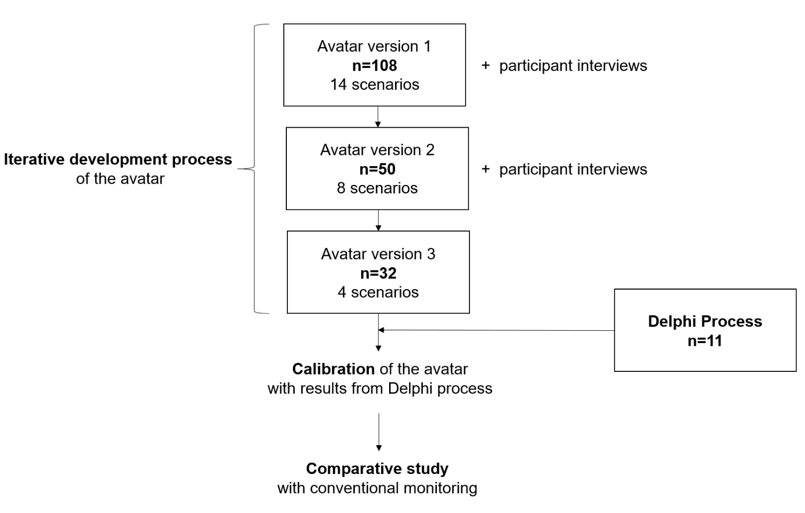
Delphi process for the safe calibration of the visualisations

Introduction

After we identified a visualisation condition with an inter-rater-reliability of >94% for each of the 30 vital sign visualisations in avatar version 3, we aimed to calibrate these visualisation conditions with safe numerical vital sign values.

The association of the visualisations with safe vital sign values was an essential requirement to make the technology useful for patient monitoring and to compare its performance to conventional patient monitoring in the primary study reported in the main manuscript.

Methods

Study design

To determine safe numerical vital sign values for the calibration of the avatar, we chose to conduct a Delphi process⁵ with experienced physician anaesthetists from both study sites.

We decided to base the calibration of the technology on the clinical anaesthesia experience of a group of specialists rather than on textbook values, which differ significantly between sources and are hard to validate.

Procedure

We invited the selected group of experienced anaesthetists to aid in the Delphi process in person or via telephone. We sent them an e-mail including a standardised description of the project and an Excel document, which we requested them to complete and to return. The e-mail also explained the specific reason for the Delphi process, namely the initial calibration of the visualisations of the avatar and described the task we asked them to complete. We did not disclose to the participants who else participated.

The task required the experts to name, for all 11 vital signs of the avatar, the ranges that they considered safe in every imaginable situation for a grown-up ASA category I, i.e., a healthy patient and category II patient, i.e., a patient with a mild systemic disease, under general anaesthesia. The experts identified a lower and upper safe value for every vital sign to define a range. We encouraged them to give additional information and to comment their decisions.

After the initial round, we sent the ranges we established from the responses again to all participants asking whether they considered them safe.

Results

Study participants

Eleven anaesthesia experts (7 from the USZ, four from the KSW) participated in the Delphi process. Their median clinical anaesthesia experience was 18 years, with an interquartile range from 12 to 30 years.

Calibration

During the last round, all experts agreed that they considered the proposed vital sign ranges safe for monitoring ASA category I and II patients under general anaesthesia.

Consequently, we used these ranges for the calibration of the avatar. Table 8 outlines the numerical values identified in the Delphi process and how we used them to calibrate the avatar. To make the ranges we used for the calibration as safe as possible, we based the thresholds for calibration at >90% inter-rater agreement, eliminating only the most extreme answer for each vital sign category, i.e., too low, normal or too high. For example, if one expert indicated that the threshold for body temperature too high should be at 37°C and 10 experts indicated it should be at 37.5°C, we set the threshold at 37.5°C. Thereby basing the calibration on the opinion of 10 out of 11 experts. If, however, two experts had indicated the threshold for body temperature “too high” should be at 37° and nine experts indicated it should be at 37.5°, we would have used 37°C as the threshold.

This approach was conservative and following a safety-first philosophy. We intended for the avatar to inform a user quickly when a vital sign approaches its limit.
References

- Endsley MR, Jones DG. Designing for Situation Awareness: An Approach to User-Centered Design, Second Edition. Boca Raton, London, New York: CRC Press, 2011
- Wittgenstein L. Tractatus logico-philosophicus. London: Routledge & Kegan Paul, 1922
- Frank AD, Dwayne RW. The Right Picture Is Worth a Thousand Numbers: Data Displays in Anesthesia. Hum factors 2006; 48: 59-71
- Tscholl DW, Weiss M, Spahn DR, Noethiger CB. How to Conduct Multimethod Field Studies in the Operating Room: The iPad Combined With a Survey App as a Valid and Reliable Data Collection Tool. JMIR Res protoc 2016; 5: e4
- Clayton MJ. Delphi: a technique to harness expert opinion for critical decision‐making tasks in education. Educ Psychol-UK 1997; 17: 373-86

