Supplementary material for manuscript:

Using an animated patient avatar to improve care providers’ perception of vital sign information.

Table of Contents:

Supplementary Tables:

Supplementary Table 1: The visualisation conditions and numerical values displayed in the four scenarios.

Supplementary Table 2: Subgroup analysis: Comparison of the outcome measures of Visual Patient naïve and non-naïve participants.

Supplementary Figures:

Supplementary Figure 1: Screenshots of the iPad-based data collection tool.

Supplementary Figure 2: A flowchart of the study procedure.

Supplementary Figure 3: Visual Patient compared to conventional monitoring:
Results on a scenario level
Supplementary Table 1: The visualisation conditions and numerical values displayed in the four scenarios.
MmHg=millimetres of mercury, ml=millilitre, kPa=kilopascal. BIS=bispectral index system, SpO2=peripheral oxygen saturation, mV=millivolt, TOF=train of four.

 | 1. Pulse rate  Visualisation  Condition  Numerical  value  (min-1) | 2. Arterial blood pressure  Visualisation  Condition  Numerical  value (MAP) [mmHg] | 3. Central venous pressure  Visualisation  condition  Numerical  value  (mmHg) | 4. Respiratory rate  Visualisation  condition  Numerical value  (min-1) | 5. Tidal volume  Visualisation  condition  Numerical value  (mL) | 6. Expiratory CO2 concentration  Visualisation  condition  Numerical value  (kPa) | 7. Body temperature  Visualisation  condition  Numerical value  (°C) | 8. Brain activity  Visualisation  condition  Numerical value  (BIS) | 9. Peripheral oxygen saturation  Visualisation  condition  Numerical value  (%SpO2) | 10. ECG ST-Segment  Visualisation  condition  Numerical  value  (mv) | 11. Neuromuscular relaxation  Visualisation  condition  Numerical  value  (%TOF)
Scenario 1  (3 seconds) | safe  69 | safe  117/70 (86) | too high  21 | safe  15 | safe  543 | safe  4.5 | safe  36.8 | low  24 | too low  67% | safe  0.1 | no relaxation  100
Scenario 2  (3 seconds) | too high  261 | Safe  125/76 (92) | too low  1 | safe  13 | safe  410 | too high  9.3 | too low  33.4 | high  99 | too low  77 | safe  0.1 | relaxed  26
Scenario 3  (10 seconds) | too high  257 | too high  247/173 (197) | safe  8 | safe  11 | safe  552 | too high  12.7 | safe  37.2 | low  47 | too low  74 | abnormal  -0.9 | relaxed  41
Scenario 4  (10 seconds) | too low  13 | too low  36/5 (14) | safe  8 | safe  12 | safe  452 | safe  4.4 | too high  41.4 | high  96 | safe  96 | safe  0.0 | no relaxation  94

Supplementary Table 2: The results of the subgroup analysis: Visual Patient (VP) naïve vs. non-naïve participants. Prior experience with the avatar during its iterative development process did not affect the results.
Diagnostic certainty: 0=very uncertain, 1=uncertain, 2=certain, 3=very certain. IQR=interquartile range, TLX=Task Load Index.

 | VP  (non-naïve participants)  n=17 | VP  (naïve participants)  n=15
Correct recalls  Median (IQR) | 10 (8-10) | 9 (8-10)
 | p=0.20 (Mann-Whitney-U test)
Diagnostic certainty  Median (IQR) | 2 (1-3) | 2 (1-3)
 | p=0.58 (Mann-Whitney-U test)
Raw NASA TLX  Median (IQR) | 61 (39-68) | 59 (50-65)
 | p=0.92 (Mann-Whitney-U test)

Supplementary Figure 1: Two screenshots of the iPad-based data collection tool. A: The iPad asks the participant to indicate which vitals they perceived in the scenario codenamed "Passionfruit." B: The iPad asks to score the questions of the NASA TLX score for the scenario codenamed "Acerola."
TLX=Task Load Index.

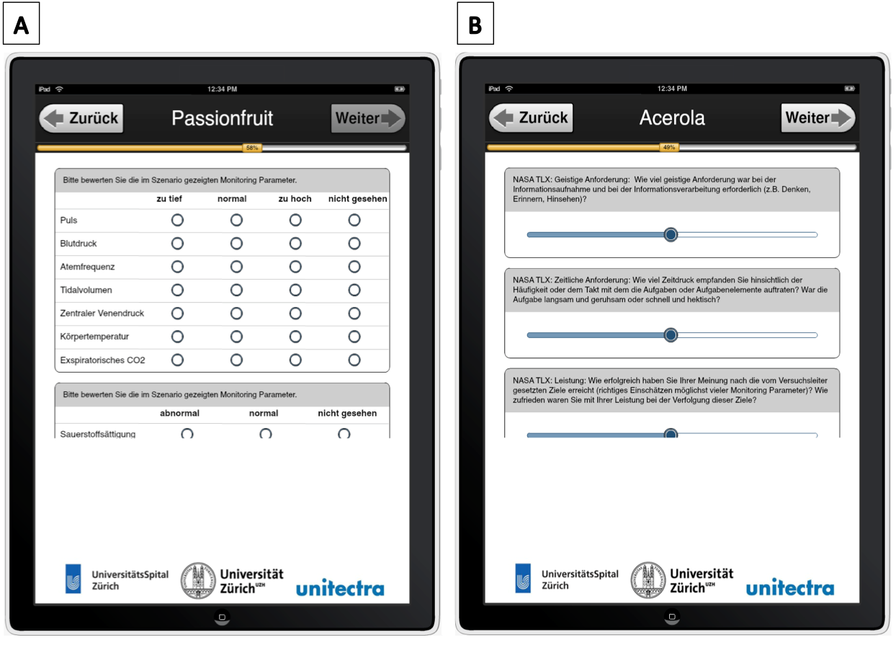
Supplementary Figure 2: Flowchart of the study procedure.
USZ=University hospital of Zurich (study centre 1), KSW=Kantonsspital Winterthur (study centre 2).

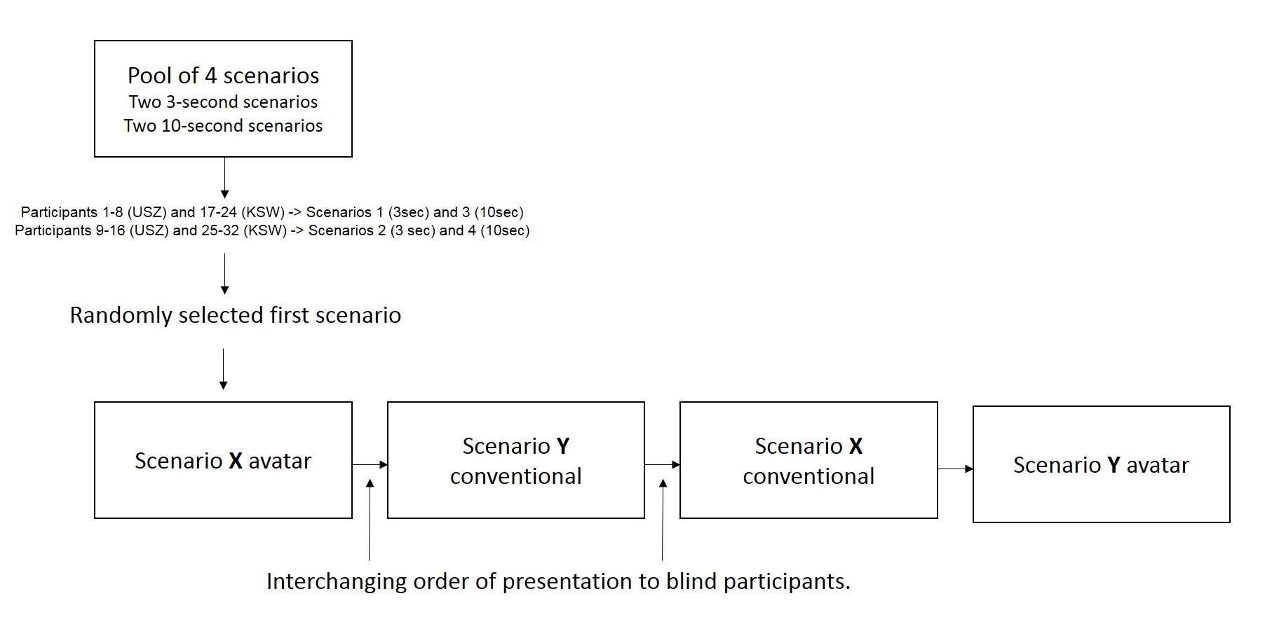

Supplementary Figure 3: Visual Patient (VP) compared to conventional monitoring (CM):
Results on a scenario level. For all outcome measures (vital sign perception, perceived confidence and perceived workload) N for each scenario was 16.
Diagnostic certainty: 0=very uncertain, 1=uncertain, 2=certain, 3=very certain. IQR=Interquartile range.

