Multimedia Appendix 1:
Using a wearable-based animated patient avatar to improve patients’ perception of vital sign information.

Johannes Köhler†, Max Ebensperger†, Cynthia A. Hunn, Achilles Delis, Florian Piekarski, Florian J. Raimann, Gregor Massoth, Kai Zacharowski, David W. Tscholl, Tadzio R. Roche*

† These authors contributed equally to this publication

*Corresponding author:
Tadzio R. Roche
Email: tadzio.roche@gmx.de
Running title: Visual Patient Avatar Improves Vital Sign Awareness in Patients

Table S1: Scenarios and vital sign deviations Abbreviations: ABP, Ambulatory Blood Pressure; RR, Respiratory Rate; HF, Heart Rate.
Scenario | RR | HR | SpO2 | ABP | Rhythm | Temperature
A, B | normal | high | low | normal | AFib | normal
C, D | high | normal | low | normal | normal | low
E, F | normal | high | low | High | Tachycardia | normal
G, H | normal | low | normal | low | Bradycardia | high

Table S2: Results of correctness for Conventional and Visual Patient Wearable per center.
 | Conventional correct median percentage [Q1, Q3] | VPW correct median percentage [Q1, Q3] | P-value
Center 1 | 50% [42, 67] | 67% [50, 83] | <0.001
Center 2 | 50% [50, 75] | 75% [50, 83] | 0.007
Center 3 | 25% [17, 42] | 33% [33, 50] | 0.004

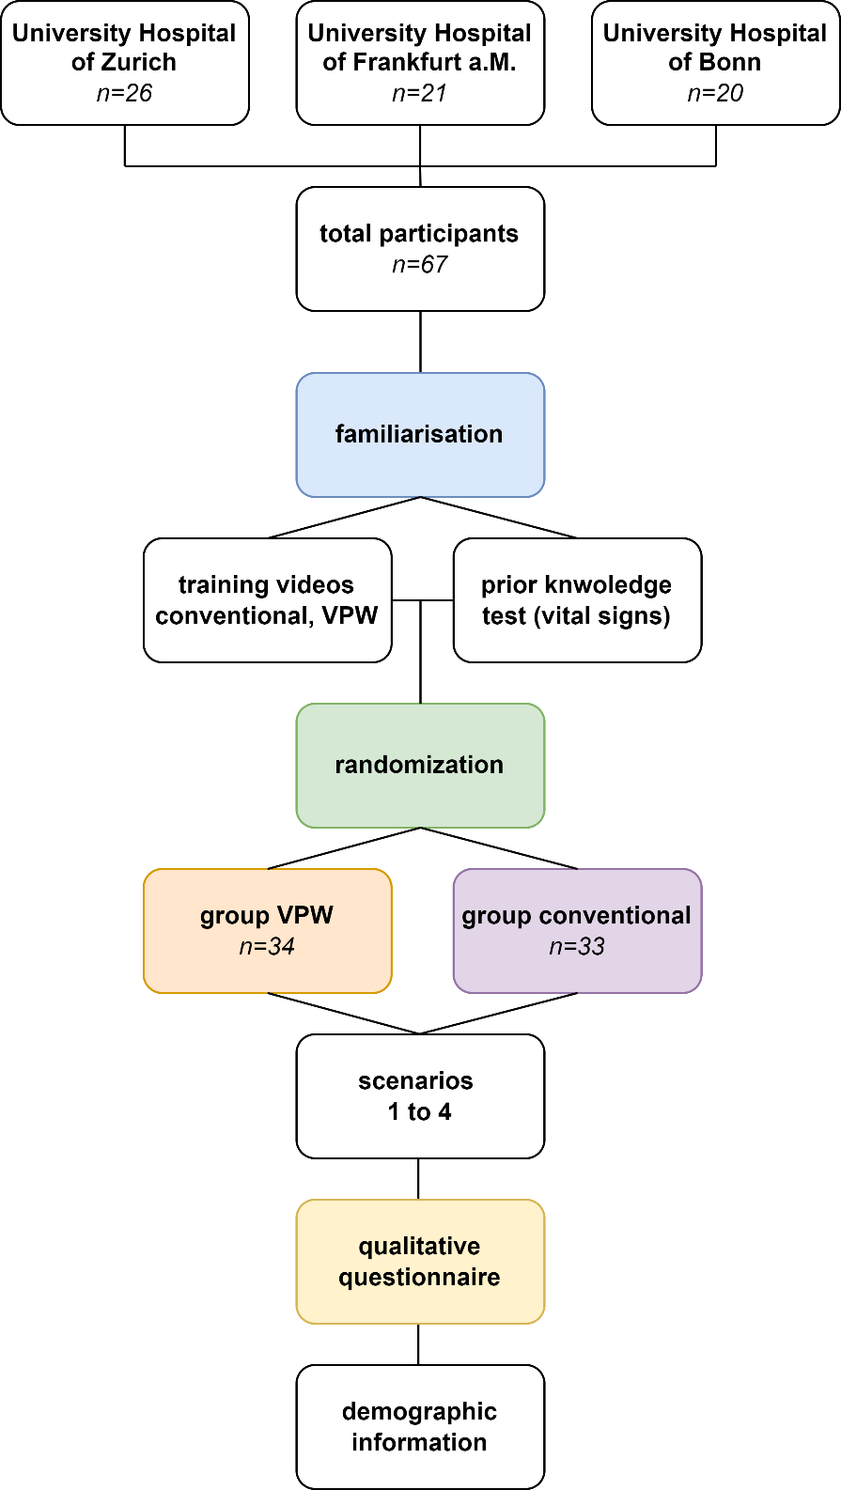
Figure S1: Flowchart of Study design

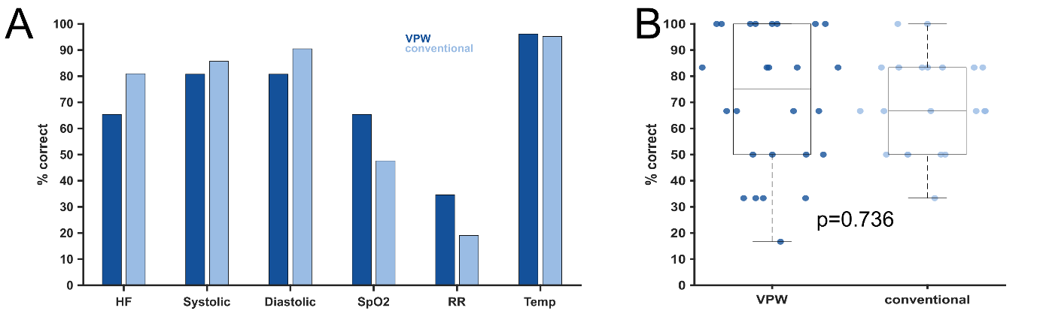
Figure S2: Bar Chart and Boxplot measuring prior knowledge of participants of physiological (“normal”) ranges of different vital signs.
A) Bar charts for the different vital signs
B) Box charts indicating no significant difference for prior knowledge (p=0.736).
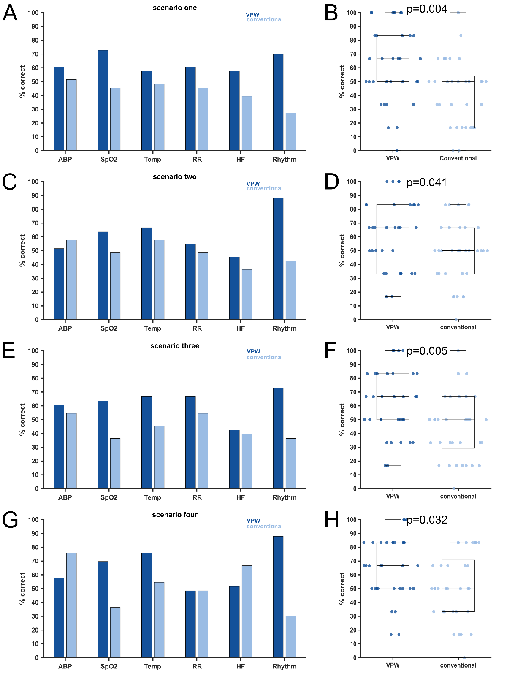
Figure S3: Bar charts and Boxplots indicating percentage correctness for different scenarios
A) and B) Scenario 1
C) and D) Scenario 2
E) and F) Scenario 3
G) and H) Scenario 4

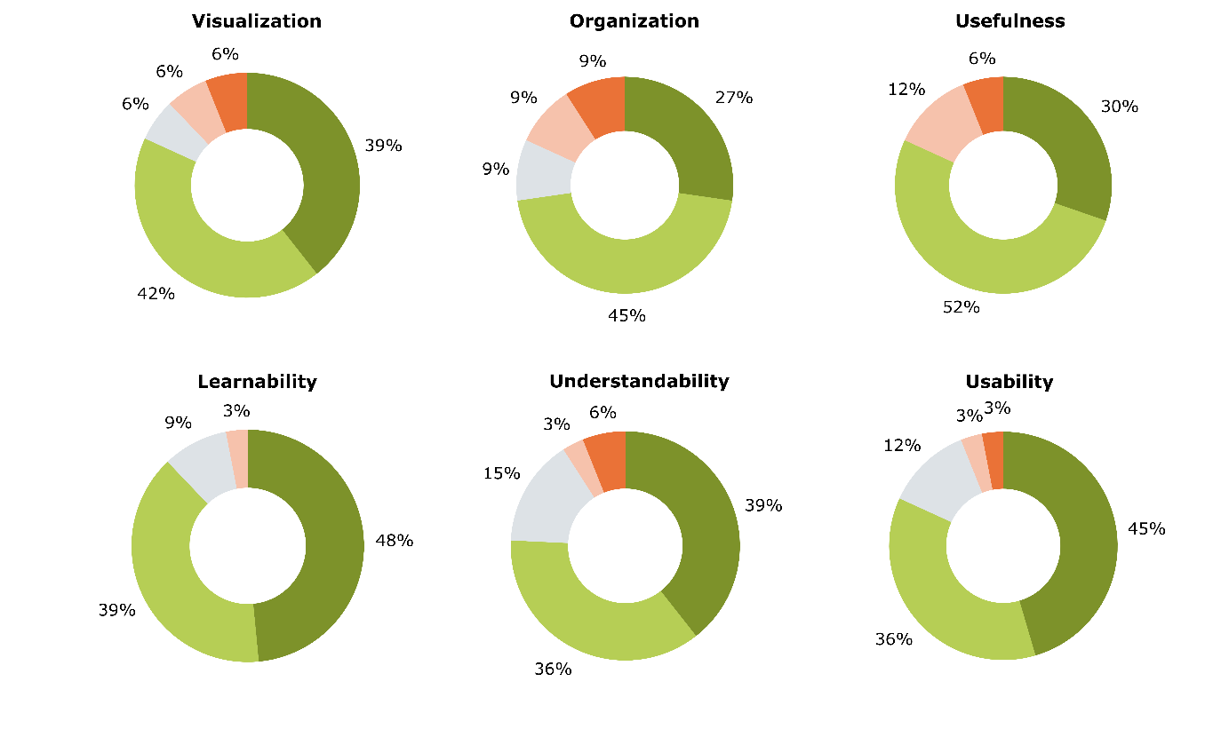
Figure S4: Donut charts showing Likert rating scale results (maximum 5 points) for different aspects of the Visual Patient Wearable. Colors: dark green (5 points), light green (4 points), gray (3 points), light red (2 points), and dark red (1 point).

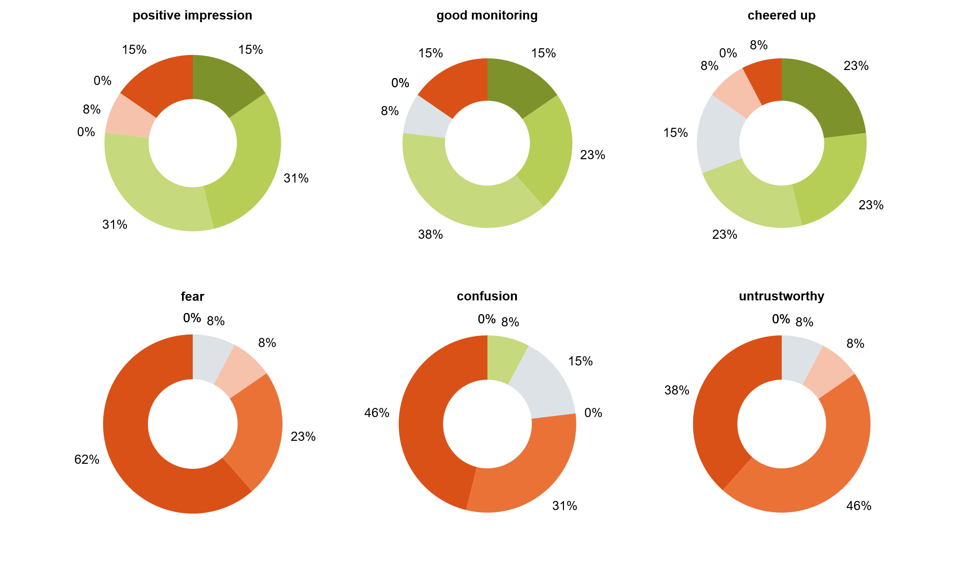
Figure S5: Donut charts illustrating Likert scale ratings (maximum score: 7) for various aspects of the Visual Patient Avatar, based on participants’ firsthand experiences during their own anaesthesia in the operating room. Colours: dark green (7 points), green (6 points), light green (4 points), grey (3 points), red (2 points), light red (1 point), no colour (0 points, 0% for all categories).

