Avatar-based versus conventional vital sign display in a central monitor for monitoring multiple patients: A multicenter computer-based laboratory study.

Table S1: The numbers and percentages with which the participants correctly recalled the individual vital signs in the 10-second and 30-second scenarios. Each participant evaluated each vital sign a total of eight times (four times with either monitoring technology). In the 10-second scenarios, two of the 11 vital signs were more frequently recognized using conventional monitoring. In the 30-second scenarios, four of the 11 vital signs were more frequently recognized using conventional monitoring.
 | 10-second scenarios  N=16 |  | 30-second scenarios  N=22
 | conventional | avatar | conventional | avatar
Pulse rate (%) | 29 (45%) | 44 (69%) | 75 (85%) | 75 (85%)
Blood pressure (%) | 41 (64%) | 27 (42%) | 78 (89%) | 53 (60%)
Oxygen saturation (%) | 37 (58%) | 46 (72%) | 67 (76%) | 85 (97%)
Central venous pressure (%) | 1 (2%) | 24 (38%) | 45 (51%) | 55 (63%)
ECG ST-segment (%) | 13 (20%) | 21 (33%) | 58 (66%) | 58 (66%)
Respiratory rate (%) | 8 (13%) | 17 (27%) | 54 (61%) | 44 (50%)
Tidal volume | 15 (23%) | 15 (23%) | 68 (77%) | 57 (65%)
Expiratory CO2 concentration (%) | 35 (55%) | 25 (39%) | 66 (75%) | 51 (58%)
Brain activity (%) | 12 (19%) | 38 (59%) | 51 (58%) | 70 (80%)
Temperature (%) | 20 (31%) | 45 (70%) | 74 (84%) | 84 (95%)
Neuromuscular relaxation (%) | 6 (9%) | 33 (52%) | 43 (49%) | 54 (61%)

Figure S1: Perceptive performance in the 30-second scenarios. The dotted lines represent the median number of correctly recalled vital signs, which was 16 with avatar-based monitoring and 15 with conventional monitoring (paired Student's t-test, p = 0.055, effect size d=0.33).
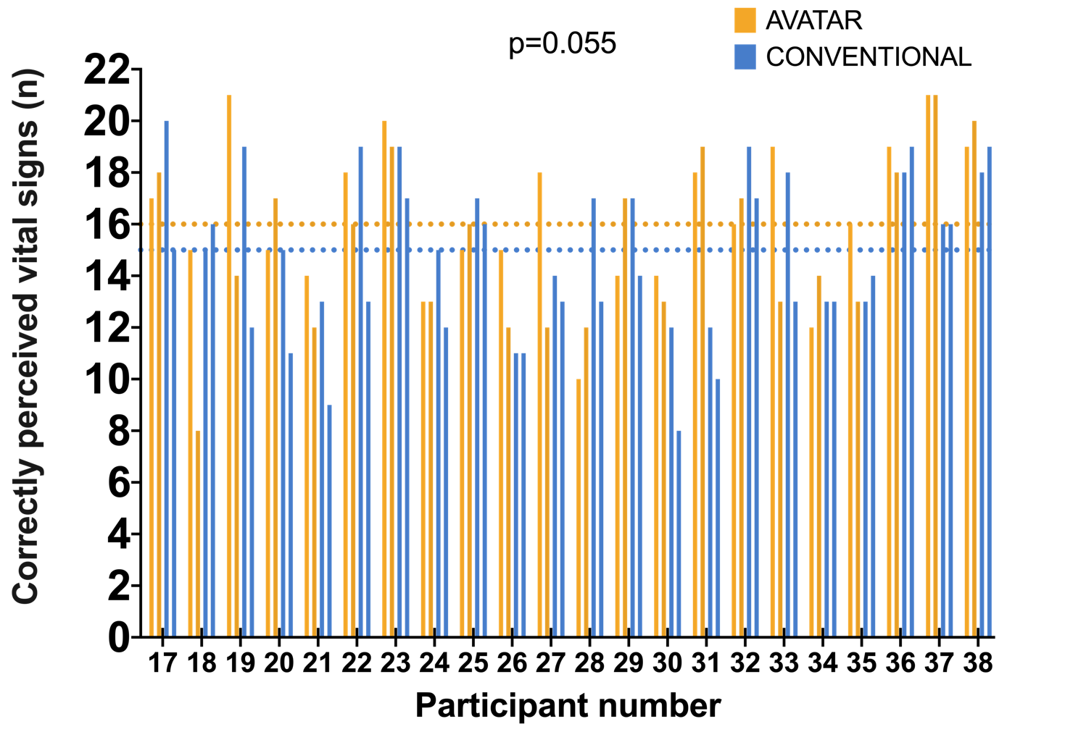
Figure S2: Perceived workload in the 30-second scenarios. The dotted lines represent the median NASA-TLX score, which was 60 with avatar-based monitoring and also 60 with conventional monitoring (paired Student's t-test, p = 0.59, effect size d=0.13).
