Supplementary Material to: “Anaesthesia Professionals’ Perspectives on ECG Interpretation and Arrhythmia Situation Awareness with Visual Patient Heart: A Qualitative Multicentre Study.”
Semi-structured Survey Guide
Purpose of the survey
The purpose of the interview is to explore anaesthesia professionals’ perceptions of the Visual Patient Heart technology, with a particular focus on perceived benefits, limitations, and areas for further improvement related to ECG interpretation and arrhythmia situation awareness.
Interview format
Semi-structured surveys are conducted. All participants are asked the same initial open-ended questions. Follow-up questions and prompts may be used to clarify responses or encourage elaboration.
Core questions
- What advantages do you see in using Visual Patient Heart?
  - Possible prompts (if needed):
    - Perceived usefulness in routine clinical work or critical situations
    - Impact on situation awareness
    - Effects on ECG interpretation
- Where do you see weaknesses or areas for improvement in the technology?
  - Possible prompts (if needed):
    - Suggestions for future development
    - Design, usability, or information content
    - Limitations in specific clinical scenarios
Closing prompt
- Is there anything else you would like to add regarding your experience or impressions of Visual Patient Heart?
Note
The interview guide is specifically developed for this study and has not been published previously.

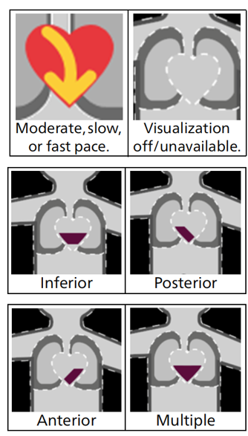
Description of the existing Visual Patient Avatar heart visualization
The heart is colored red, and the yellow arrow inside the heart moves downward. The arrow's pace can be moderate, slow, or fast, depending on the patient’s condition. A small dark shape is displayed within the heart, depending on the location of the ST-segment elevation.

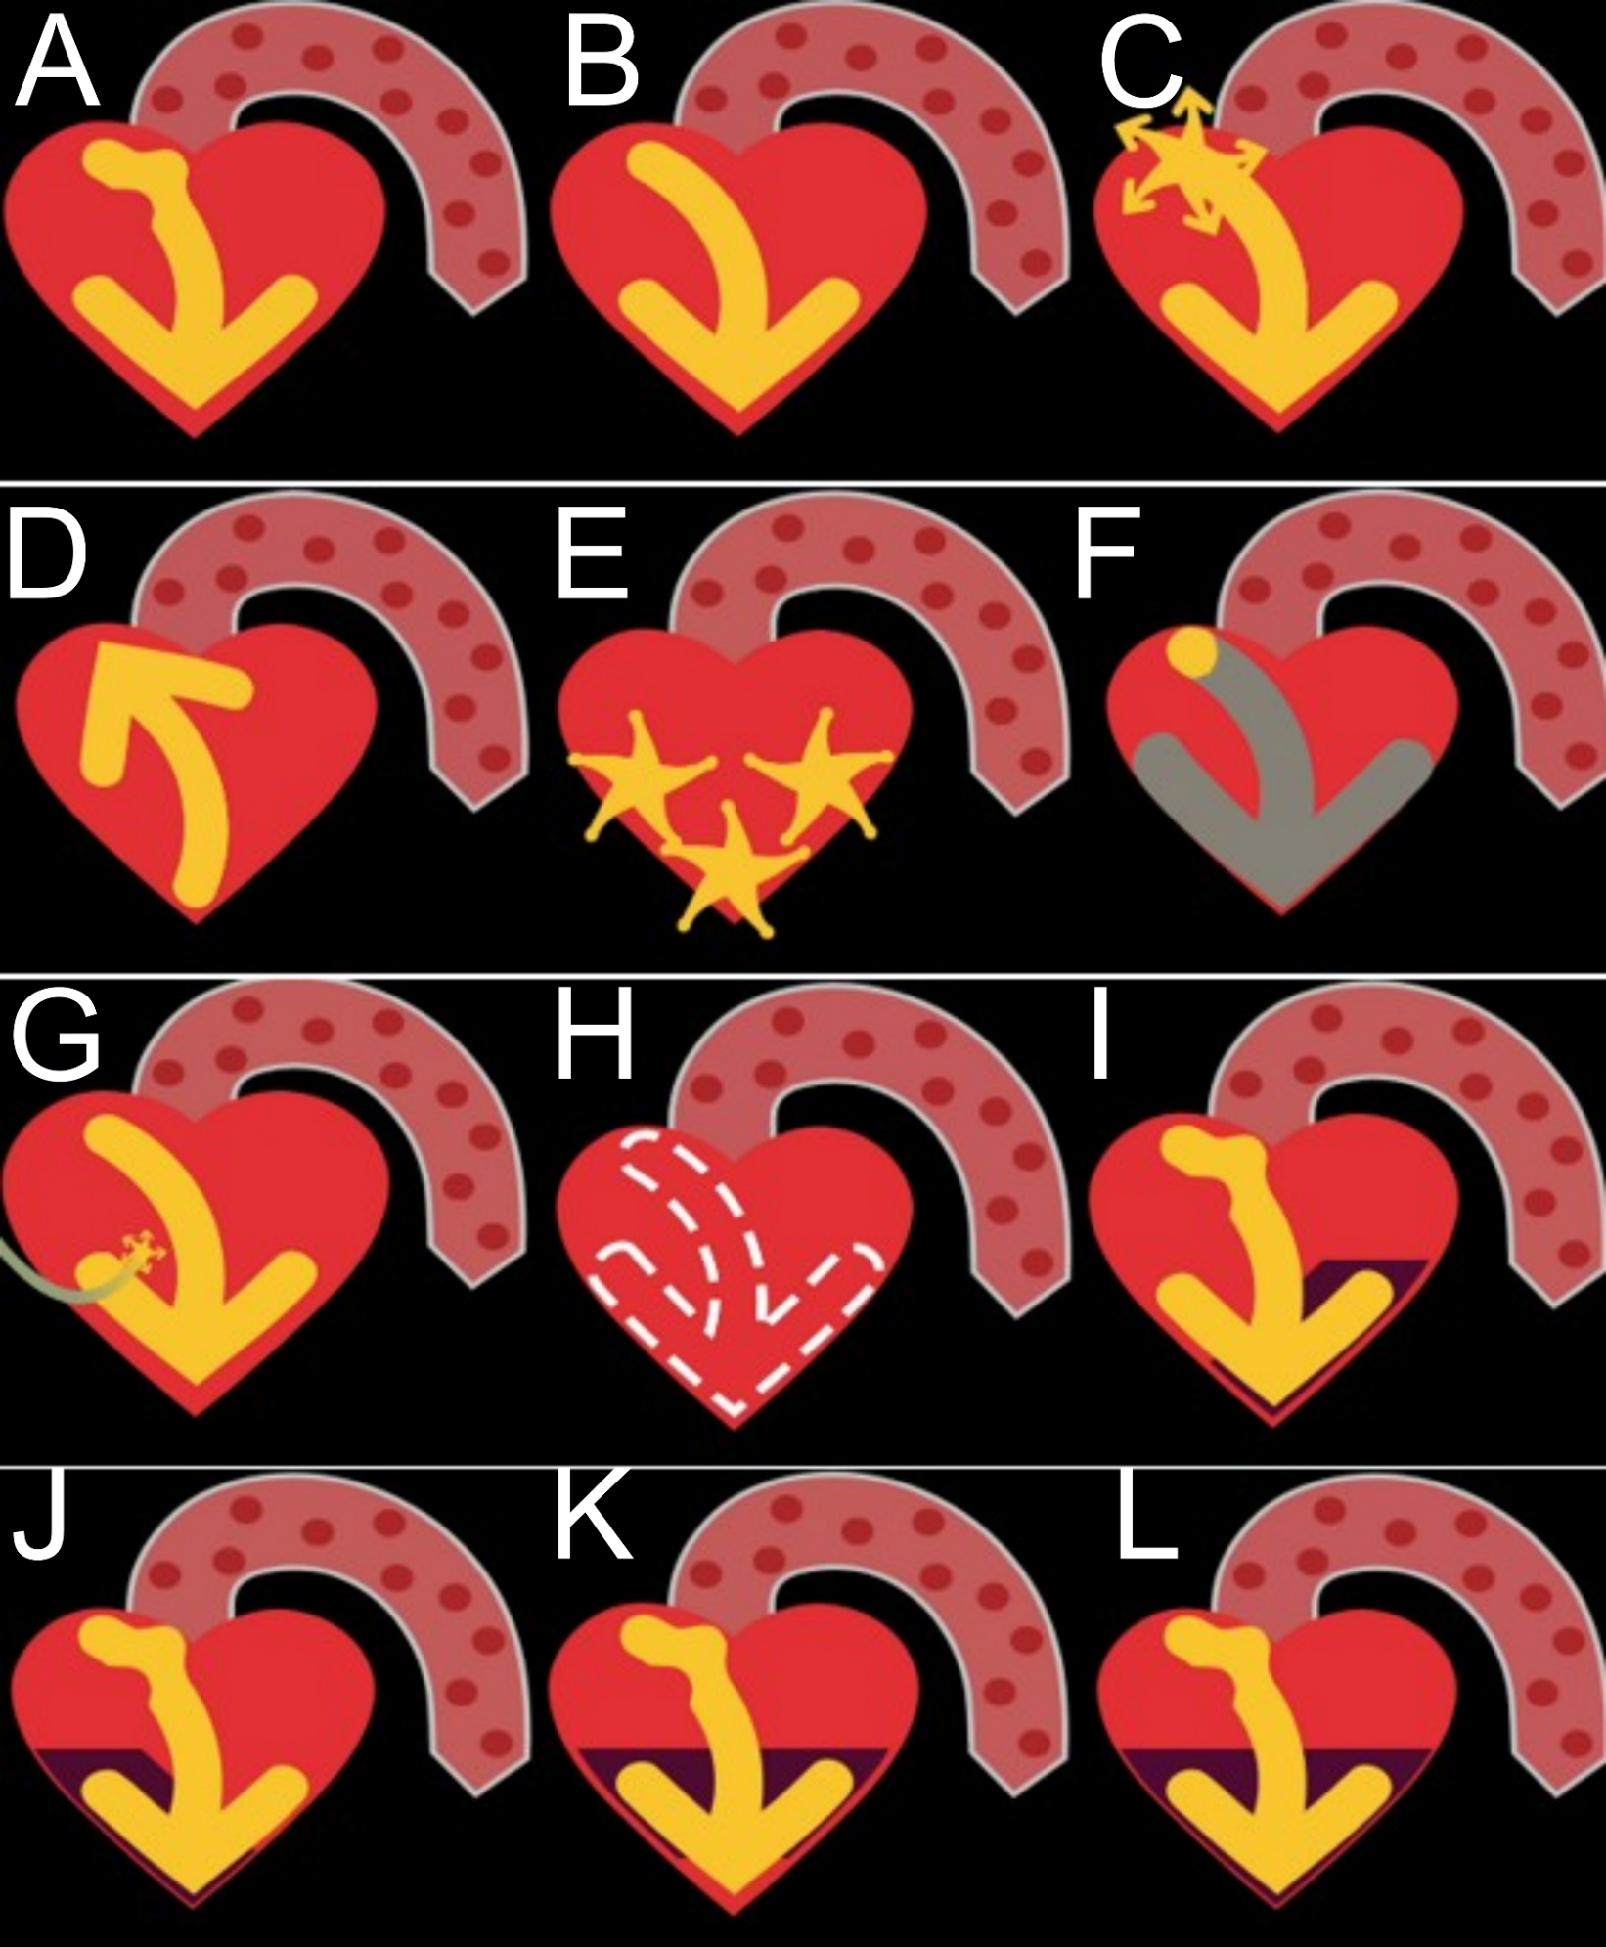
Description of the new Visual Patient Avatar Heart Visualization.
Many visualizations depend on the speed of the animation. This cannot be shown in a still image; see the Supplementary Video.
A Sinus Rhythm, Sinus Tachycardia, Sinus Bradycardia
B Supraventricular Tachycardia
C Atrial Fibrillation
D Bigeminus, Trigeminus, VES Couplets, Ventricular Rhythm, Non-sustained Ventricular Tachycardia, Ventricular Tachycardia
E Ventricular Fibrillation
F Asystole
G Pacemaker (capture and non-capture)
H Unknown status
I ST-anomaly anterior
J ST anomaly posterior
K ST anomaly inferior
L ST Anomaly multiple

